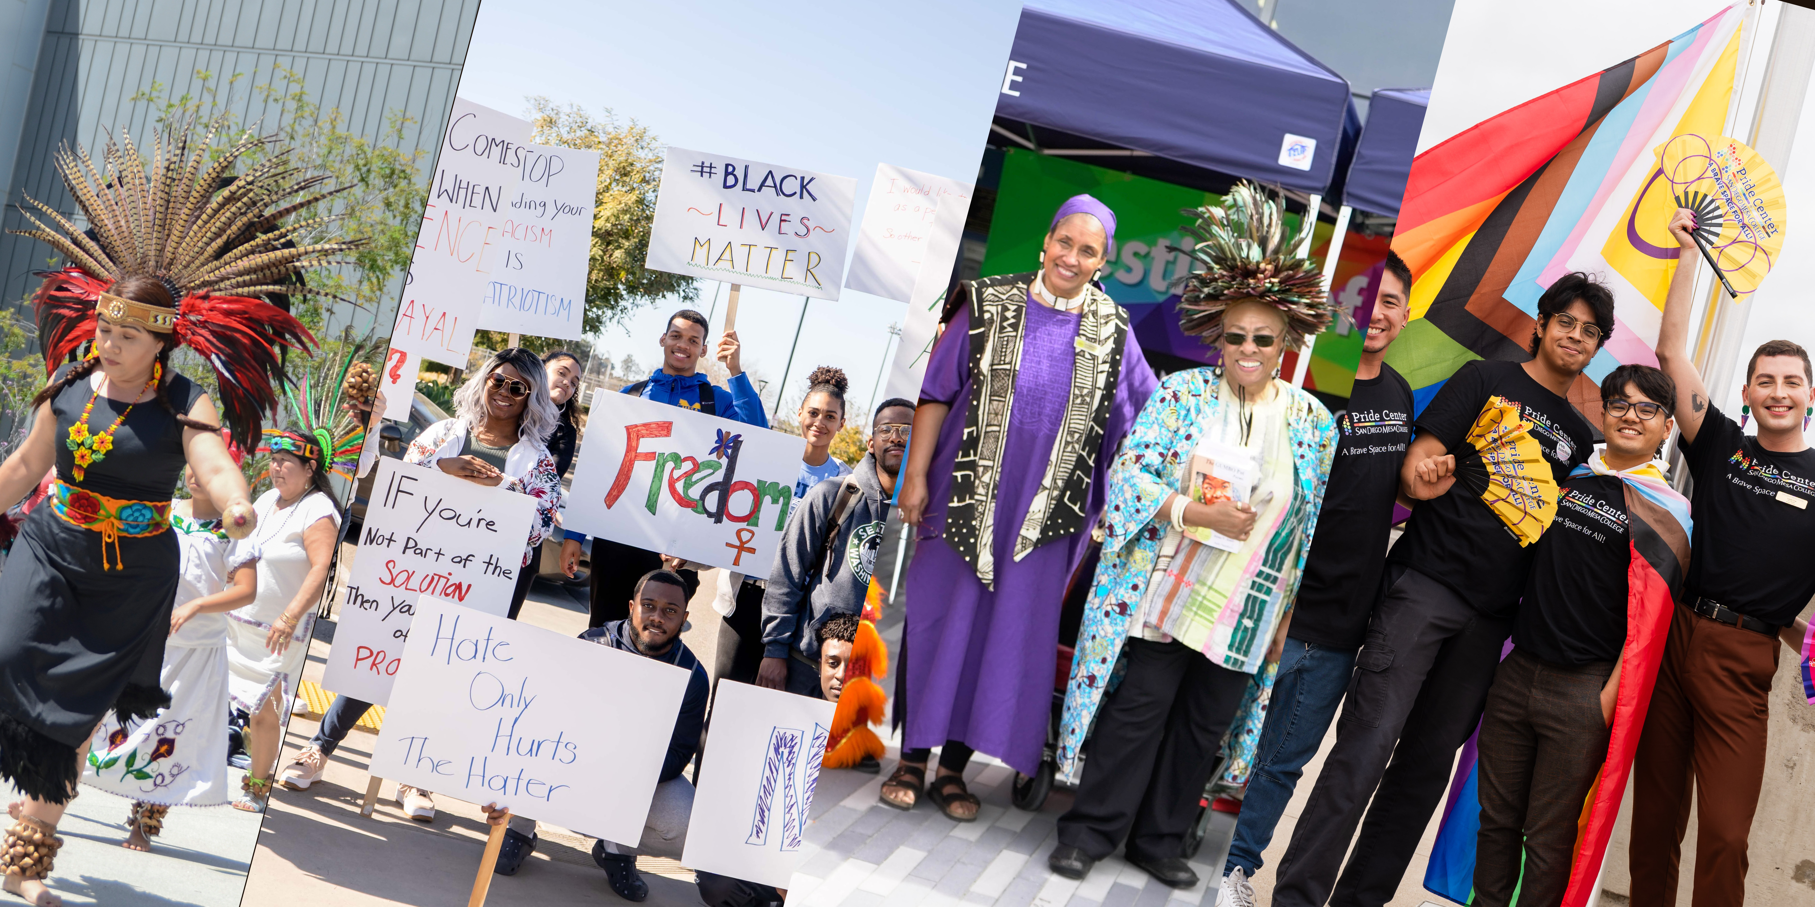
NOVEMBER CELEBRATIONS
Native American Heritage Month
Dia de Los Muertos (Nov. 2nd)
Trans Awareness Week (2nd Wk. Nov.)
Int’l Day for Tolerance (Nov. 16th)
Transgender Day of Remembrance (Nov. 20th)
National Day of Mourning (Nov. 24th)

Officers

Ashanti Hands Ex-Officio Member

Judy Sundayo, Co-Chair

Jorge Villalobos, Co-Chair

Blythe Barton, Secretary

General Members

Samrawet Ayelew

Blythe Barton

Kevin Branson

Michael Brewer

Jennifer Carmichael

Katlin Choi

Alison Damoose

Maryam Fazel

Somaya Fazel

Sakeenah Gallardo

Veronica Gerace

Michael Harrison

Erika Higginbotham

Xavier Hunt

Christina Huynh

Cathy James

Candace Katungi

Gloria Kim

Lucio Lira

Thekima Mayasa

Victoria Miller

Travis Nichols
Edeama Onwuchekwa
Hannah Padilla Barajas
Claudia Perkins

Waverly Ray
Denise Rogers
Kim Lan Salas
Dora Schoenbrun-Fernandez
Leland Simpliciano
Talal Slaiby
Leslie Styles
Jorge Villalobos

Community Members

Jacob Babauta

Robyn Bolden

Taylor Carpenter

Olivia Puentes-Reynolds

Afrah Saleh

Tanis Starck

Consultants
Joel Arias
Angie Avila
Abdulmalik Buul
Ailene Crakes
Leticia Diaz
Geoffrey Johnson
Janue Johnson
Jennifer Nichols Kearns
Cesar Lopez
Larry Maxey
Raquel Sojourner
Pahua Vang

Meeting Agenda
Friday, November 3, 2023
9:00 – 11:00 AM, via Zoom

- Welcome, Check-in, Land Acknowledgement, Celebration Videos
- Approval of Minutes & Agenda
- Subcommittee & Special Project Reports
- AANAPISI Grant (Leland)
- Asian Pacific Islander American Committee (Katlin)
- Disability Support Programs & Services (Erika)
- Fine & Performing Arts Committee Update (Blythe, Denise)
- International Education (Dora)
- Lactation Rooms (Lauren)
- LGBTQIA Updates (Lucio)
- Marketing Subcommittee (Vickie)
- Organizational Subcommittee: (Judy)
- Personal/Professional Learning Subcommittee (Edeama)
- Site Compliance (Claudia)
- Special Projects / Events (Mesa’s 60th; Black History Month; Cultural Unity Week; Festival of Colors)
- Student Voices (Trina, Suzi)
- Women’s Studies Advisory Committee (Gloria)
- Event Review What did you attend? What did you learn?
- Street Dance: Whacking, Oct. 9th 1-2:30 pm, Pride Center
- DEBER Chicanx Panel: Testimonials of Chicanx Professionals, Oct. 10th 12:30 – 2 AVANZA
- Advocacy Fair, Oct. 11th, 10 am – 2 pm, Quad
- Parent Cafe, Oct. 11, & 18; Nov.1st
- Against the Wall, w/Jenn Budd, migrant rights activist, Oct. 11th 9:30 – 11, MC-211
- Afro Latinx, Oct. 11, 12-2, AVANZA
- Coming Out Workshop, Oct. 11, 1-2 pm, Pride Center, D-102
- Empowering Minds-Black Leadership Fellows, Oct. 18, Nov. 1, 15, 29, Dec. 6, I401, 1-2 pm
- Restorative Action Week, Student Affairs & Associated Students, Oct. 9th – 13th Quad

- Upcoming Events Please share with your students and colleagues!
- Kumeyaay Flag Raising, Nov. 1st ; Ceremony, Nov. 14th 1:30 – 2pm Administration Office Flag Pole
- Native Student Panel, Nov. 8th 12 – 1 pm, SB-105
- International Education Fair Nov. 15th 10 -3 QUAD; Study Abroad Panel, Nov. 15th 10 – 12:30, BT-101
- Parent Cafe, Nov. 8, & 15, AS Conference Rm. I4-409A
- Film/Discussion: Killers of the Flower Moon, Nov. 29th 12 – 1 pm, via zoom
- Native American Heritage Month Display, 3rd floor, SB Bldg.
- NCORE 2024 – May 28 – June 1, 2023, Honolulu, HA

Next Meeting, December 1st, 9:00 – 11:00 AM, via Zoom!
COMMITTEE FOR DIVERSITY, ACTION, INCLUSION & EQUITY
(C D A I E)

The Committee for Diversity Action, Inclusion & Equity (CDAIE)
Instituted by Donna Duchow, 2010; Institutionalized as a Permanent Governance Committee, 2015
Reports to: President’s Cabinet (PCAB) and the Academic Senate
Oversight by: Leticia Diaz, Dean of Student Equity & Transformation (SET)
Co-Chairs: Judy Sundayo and Jorge Villalobos (2023)
_____________________
CDAIE VALUES: (Endorsed by CDAIE, 2015)
- We value our individual differences.
- We value our universal similarities.
- We value learning about each other.
- We value being able to coexist harmoniously.
- We value being inclusive of others in our lives.
- We value cultural proficiency.
- We value helping each other to succeed.

CDAIE VISION: (Endorsed by CDAIE, 2015)
- That students, faculty and staff will feel supported, comfortable, and included on campus.
- That individually and institutionally, our campus will strive toward cultural awareness, proficiency, and practice.
- That students, faculty and staff will actively include each other in all aspects of the campus community.
- That diversity and inclusion will be embedded into the fabric of the college, including the structure, curriculum, and research.
- That our campus community (students, faculty, and staff) will be reflective of the larger community’s diversity measures.
CDAIE MISSION STATEMENT: (Endorsed by CDAIE, 2015)
The Diversity Committee’s mission is to develop and implement a strategy for diversity, inclusion, and equity, which is active and aligned with Mesa’s mission, vision and values. The Committee’s overarching goal is to engage and support students, faculty, and staff in the ongoing process of transforming our campus environment into one, which we envision as safe, supportive, culturally proficient, globally inclusive, and reflective of the larger San Diego community.
CDAIE GOALS: (Endorsed by CDAIE, 2015)
- To Support a Safe, Comfortable & Harmonious Campus Environment for Students, Faculty & Staff
- To Promote the Awareness and Benefits of Diversity, Cultural Proficiency & Inclusion
- To Endorse & Actively Support Equity Initiatives that Promote Inclusion & Success for Underrepresented Individuals & Diverse Groups
- To Advocate for & Actively Support the Incorporation of Diversity into the College Structure, the Curriculum & in Research
- To Canvass for a Campus Workforce that is Reflective of the Diversity of the Student Population

CDAIE OBJECTIVES (4-YEAR)
2021-2022
- Submit Update for District EEO Plan
- Initiate work on 13 Point Plan
- Obtain DEI Coordinator Reassign Time Position
- Present Equity in the Library for NCORE
- Obtain Approval for Mesa College Pride Center

2022-2023
- Open the Mesa College Pride Center
- Support First Lavender Graduation
- Follow Up on Lactation Pods
- Host Civil Dialogue Training
- Host Advocacy Fair
- Complete Land Acknowledgement

CDAIE ACCOMPLISHMENTS:
- Annual Cultural Unity Week & Festival of Colors Celebrations
- Annual Student Diversity Club Luncheon & Table Talks
- Annual Presentations at President’s Cabinet (PCAB)
2023-2024
- Host Storyscope Facilitator Training
- Continue Collaborations on Civility Discussions
- Complete collaboration on DEIA Discussion Guide
- Post and Disseminate Land Acknowledgement
- Raise Kumeyaay Flag
- Reinstitute Diversity Marketing Campaign
- Complete Storyboard for Diversity Video
- Participate in Mesa’s 60th Anniversary Celebrations
- Conduct On-Campus CDAIE Retreat

- Updates to Mesa Diversity Webpages & CDAIE Committee Webpage
- The Mesa College NCORE Video (2015)
- The New District Diversity Question for Employment Applications (2017)
- The Serenity Space (2018)
- The Lactation Room (2018); Advocacy for Lactation Pods (2023)
- Diversity Presentation, Mesa Tutors (2018)
- The “Diversity is Unity” Marketing Campaign – Merchandise (2018/19)
- Equity in the Library Flex Workshop (2019)
- The “Mesa Pride” Marketing Campaign – Merchandise (2019)
- Successful launch of Mesa College’s first LGBTQ Celebration Week (2019)
- Completed the 13 Point Strategic Action Plan for Accountability in DEI (2021)
- DEI Coordinator with Reassigned Time Approved (2022)
CHAIRS EMERITUS:
(Infinite Gratitude to our Past Chairs):
- Donna Duchow
- Denise Rogers
- Sue Shrader-Hanes
- NCORE Presentation: Equity in the Library (2022)
- Hosted Advocacy Fair (2022; 2023)
- Hosted Civil Dialogue Training and Discussions (2023)
- San Diego Mesa College Pride Center Opened (2023)
- Supported First Lavender Graduation (2023)
- Completed San Diego Mesa College Land Acknowledgement (2023)

