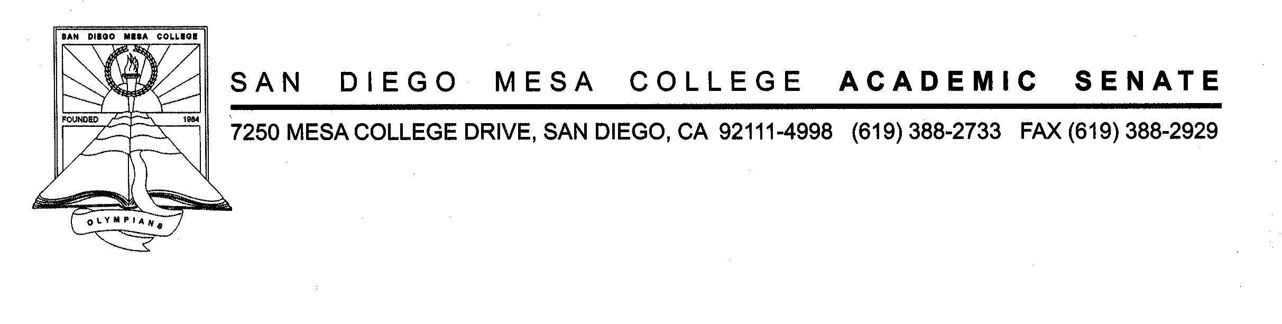

San Diego Mesa College

Academic Senate

Committee of Chairs

Room LRC 435 & [Zoom](https://sdccd-edu.zoom.us/j/93671528972)

November 9, 2022

2:30PM – 4:00PM

AGENDA

SECOND DRAFT

1. CALL TO ORDER AND WELCOM by Chair of Chairs Jill Moreno Ikari:

1. APPROVAL OF DRAFT AGENDA:

1. GUESTs:
   1. Robyn Bolden & Jordan Nash - Black Student Success Fellows Program:
   2. Dean Brian Weston - The CA Virtual Campus (CVC) and OEI:
2. APPROVAL OF DRAFT MINUTES: October 26, 2022
3. OLD BUSINESS:
   1. Californian Virtual Campus (CVC): Moreno Ikari
4. NEW BUSINESS:
   1. San Diego Mesa College “Hot Spot” Locations: Moreno Ikari
5. DEPARTMENT REPORTS:
6. PLANNING/COMMITTEE REPORTS:
   1. Academic Affairs: Gwin
   2. Academic Senate: Crocitti
   3. Curriculum Review Committee (CRC): Resch
   4. Student Services: Dougherty/Higginbotham/Rico
   5. Mesa College Facilities Committee/District Review of Services Committee:
   6. Enrollment Management and Instructional Strategic Planning Workgroup: Budzynski
   7. Planning & Institutional Effectiveness (PIE) Committee: Crocitti/Moreno Ikari
   8. President’s Cabinet: Crocitti/Moreno Ikari
   9. Program Review Committee (PRC): Miyoshi
   10. Mesa Pathways Committee: Alioto/Eskew
7. ANNOUNCEMENTS/ROUND TABLE/FOR THE GOOD OF THE ORDER:
8. NEXT COC MEETING: November 30, 2022 – MC 211 A/B & Zoom ([Fall 2022 CoC Meeting Schedule](https://www.sdmesa.edu/about-mesa/governance/academic-senate/Committee%20of%20Chairs%20FALL%202022%20DRAFT%20Meeting%20Schedule%208302022.pdf))
9. ADJOURNMENT: