**CHEM 152: WORKSHOP 3**

1. Combination/Synthesis Reactions

A + B → AB

1. Decomposition Reactions

AB → A + B

1. Single-Displacement

A + BC → C + BA

A + BC → B + AC or

1. Double-Displacement

A B+ CD → AD + CB

1. Combustion Reaction

CxHy+ O2 → CO2 + H2O

CxHyOz+ O2 → CO2 + H2O

**Ionic Equation**

* ***molecular equation*** - chemical equation showing the complete, neutral formulas for every compound in a reaction.
* ***total (complete) ionic equation*** - chemical equation showing all of the species as they are actually present in solution.
* 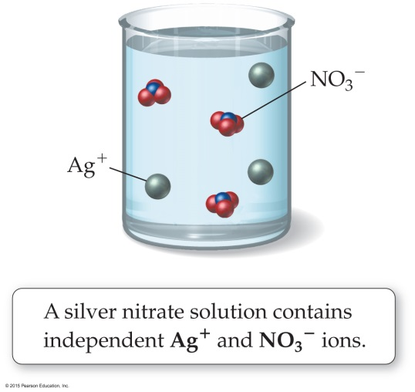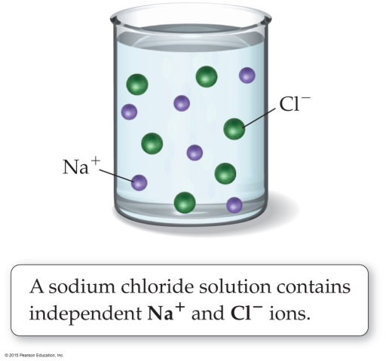***net ionic equation*** - equation showing only the species that actually participate in the reaction.

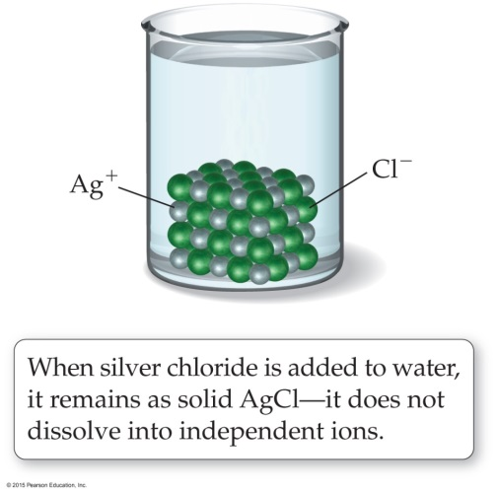

* Strong Acid – completely ionizes Weak Acid – partially ionizes

Major species: ions Major species: molecules

Minor species: molecules Minor species: ions

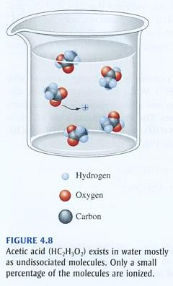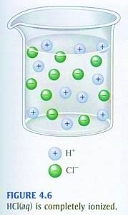

Decomposition Reactions:

H2CO3(aq) → H2O(l) + CO2(g)

NH4OH → NH3(g) + H2O(l)

H2SO3(aq) → H2O(l) + SO2(g)

(NH4)2S(aq) → 2NH3(g) + H2S(g)

Example Problems:

Write the net ionic equation for the following, if no reaction write no Reaction

1. A solution of silver nitrate is mixed with a solution of sodium chloride
2. A solution of hydrochloric acid is mixed with a solution of sodium acetate
3. A piece of zinc is added to a solution of copper(II) chloride
4. A solution of ammonium chloride is added to a solution of sodium hydroxide
5. A solution of sodium nitrate is mixed with a solution of magnesium chloride
6. A piece of iron is added to a solution of hydrochloric acid
7. Hydrochloric acid is added to calcium carbonate
8. A solution of sodium hydroxide is added to a solution of hydrochloric acid