Workshop 2 Chem 160

1. After a person spends a day or more at high altitude (with an oxygen partial pressure of 75 torr compared to normally being 100 torr), the concentration of 2,3-biphosphoglycerate in that person’s red blood cells increases. What effect would an increased concentration of 2,3-BPG have on oxygen-binding curve for hemoglobin? Explain why this adaptation would be beneficial for functioning well at high altitude.
2. Describe the Bohr effect. Make sure to include the effects of both pH and CO2 and the chemical bases for each.
3. Answer the following questions with regard to the oxygen binding curve shown below. (8 points).
   1. 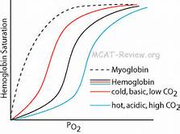If the middle black line represents Hemoglobin under normal conditions (pH7.4), which line would represent hemoglobin in the absence of 2,3-BPG.
   2. Which line would represent Hemoglobin at a pH = 7.2. Explain why (be specific, how does pH effect hemoglobin oxygen binding).
   3. Which line represent a binding curve for Myoglobin and why does it have the binding curve that it does
4. On the following graph label the Km, Vmax, and draw a representation of a competitive inhibitor. Explain what effect it has on the Km and Vmax and make sure to include why it has this effect.

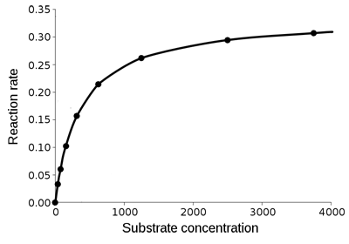

1. Catalysis of the cleavage of peptide bonds in small peptides by a proteolytic enzyme is described below in the following table. The arrow indicates the peptide bond cleaved in each case. ( 8points)

|  |  |  |  |
| --- | --- | --- | --- |
| Substrate (amino acid sequence) | Km (mM) | Kcat (1/sec) | Kcat/Km |
| EMTA↓G | 4.0 | 24 | 6.00 |
| EMTA↓A | 1.5 | 30 | 20.0 |
| EMTA↓F | 0.5 | 18 | 36.0 |

1. Explain what Km and Kcat mean, what would be the difference for high Kcat vs low Kcat and high Km and low Km.
2. If a mixture of these peptides were presented to the enzyme with the concentration of each peptide being the same, which peptide would be digested most effectively? Least effectively? Briefly explain your reasoning.
3. The experiment is performed again on another peptide with the following results:

|  |  |  |  |
| --- | --- | --- | --- |
| EMTI↓F | 9 | 18 | 2.00 |

On the basis of the data, sugeest the features of the amino acid sequence that dictate the specificity of the enzyme.

1. Chymotrypsin is a member of the class of serine proteases.

a. Why is this protease appropriately called a serine protease.

b. If you mutate His 64 (part of the active site) to Ala the KM did not have a dramatic change however the Kcat fell to one-millionth of its value for wild type. Explain what this means and why this mutation had this effect. (Hint: include details of the active site and how specificity is determined and what Kcat and Km mean)