Workshop 3 Chem 160

1. Chymotrypsin is a member of the class of serine proteases.

a. Why is this protease appropriately called a serine protease.

b. If you mutate His 64 (part of the active site) to Ala the KM did not have a dramatic change however the Kcat fell to one-millionth of its value for wild type. Explain what this means and why this mutation had this effect. (Hint: include details of the active site and how specificity is determined and what Kcat and Km mean)

1. Explain why this figure is important for understanding how enzymes behave.

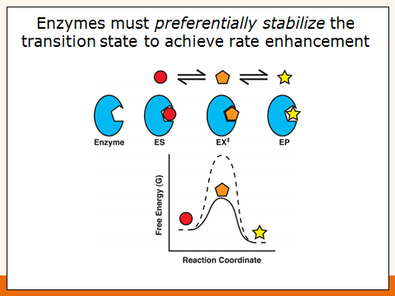

1. Suppose you are studying a protein involved in transporting ions in and out of cells. Would you expect to find the nonpolar residues in the interior of the exterior? Why? Would you expect to find the polar residues in the interior or the exterior? Why?
2. Given the following abbreviations for fatty acids. Which one would you expect to have the lowest melting point? Why? Which one would you expect to have the highest melting point? Why? (4 points)
   1. 16:0
   2. 20:0
   3. 18:1c9
   4. 18:3c9,12,15
3. Give 4 features of what is meant by the fluid mosaic model of biological membranes
4. Draw a Haworth projection of the six membered ring that is formed from D-glucose. Make sure to indicate the anomeric carbon and if it is  or . (4 points)

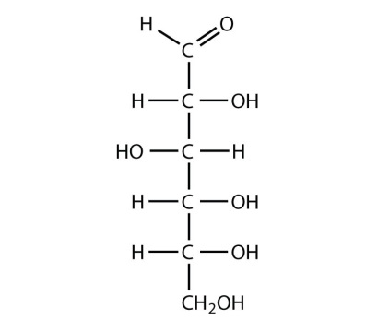

1. Draw a Haworth projection for the disaccharide given the following information (5 points)
   1. it is a dimer of glucose (look at question 5)
   2. The glycosidic linkage is (1→6)
   3. The anomeric carbon not involved in the glycosidic linkage is in the  configuration
2. For each of the following structures label them as a: wax, fatty acid, triacylglycerol, phosphoglycerides, cholesterol or Sphingolipid. Include which ones are found in membranes (6 points)

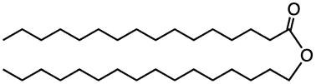

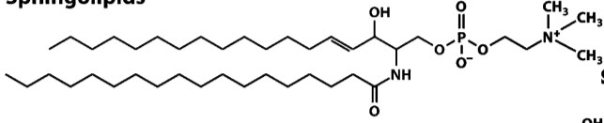

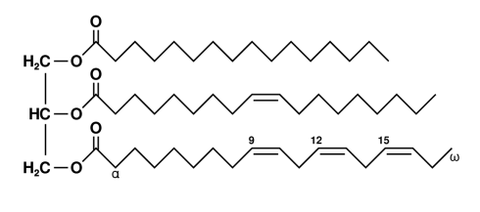

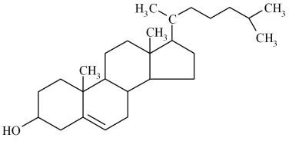

1. What is the major difference between passive versus active transport across a membrane
2. In reference to the sugar with a box around it identify an example of an epimer, and enantiomer and a diastereomer that is not an epimer and label the sugar with a box as D-aldohexose, L-aldohexose, D-ketohexose, or L-ketohexose

