**ALEKS Online Homework FAQs**

* **I have never used an online homework program. Where do I start?**
* **Do I have to purchase an access code in the bookstore?**
* **How long does the trial period last? (Temporary free access to the software)**
* **How do I access the etext?**
* **How do I get started on my homework assignments?**
* **Where do I find my grades in the program?**
* **What helpful resources are available?**
* **How do I enter fractions/exponents/square roots/logarithms?**
* **Why did the program mark my answer wrong? I think it is correct.**
* **How do I graph a line?**
* **How do I graph a parabola?**

**I have never used an online homework program. Where do I start?**

* Go the ALEKS website at [www.aleks.com](http://www.aleks.com) Click on new student
* Enter your 10-digit course code (**?????-?????**)
* Confirm your course, instructor, and school and then hit continue
* You will be asked for your access code. This is what you need to purchase. You want the 18 week (one semester) license. This will cost you $89. (I believe it is cheaper at the bookstore.)
* Enter your e-mail address and click submit
* Create your account and click continue (remember your school is San Diego Mesa College)
* Fill in your payment information (if applicable) and place your order
* Click on the big green statement that says ‘Go to ALEKS now’
* You will see your access code. Write this down somewhere. Click ‘continue sign up’
* Fill out the ALEKS information page
* You will be given a username and password. You will not be able to change your username (so write it down) but you can change your password if you wish. This username and password will be your ALEKS log-in and you will need to log-in every time you enter the ALEKS program.
* Keep pressing continue until the plug-in downloads and the tutorial comes up. You will work through the tutorial and assessment to see where you stand in the course.
* At the completion of the assessment, ALEKS will show you a pie representing the topics you know and what you still need to complete. Click on Continue My Path.
* You are ready to work on the class. Have fun and learn!!!!!

**Do I have to purchase an access code in the bookstore?**

No, you can purchase an access code from the website directly using your credit card and the directions above. However, you may want to check the bookstore as I think it is cheaper.

**How long does the trial period last? (Temporary free access to the software)**

ALEKS allows you a 14-day grace period during which you can use the system without purchasing an access code. This is helpful for students who are waiting on financial aid, or to receive an add code from the instructor. It is important to note that this does not extend your access to 20 weeks. The time you use will be deducted from your purchased access code.

**How do I access the e-text?**

From the home screen in ALEKS, there is a three-bar menu button in the upper left-hand corner. Click on this button and then click on textbook. NOTE: This is only accessible with the ALEKS 360 license.

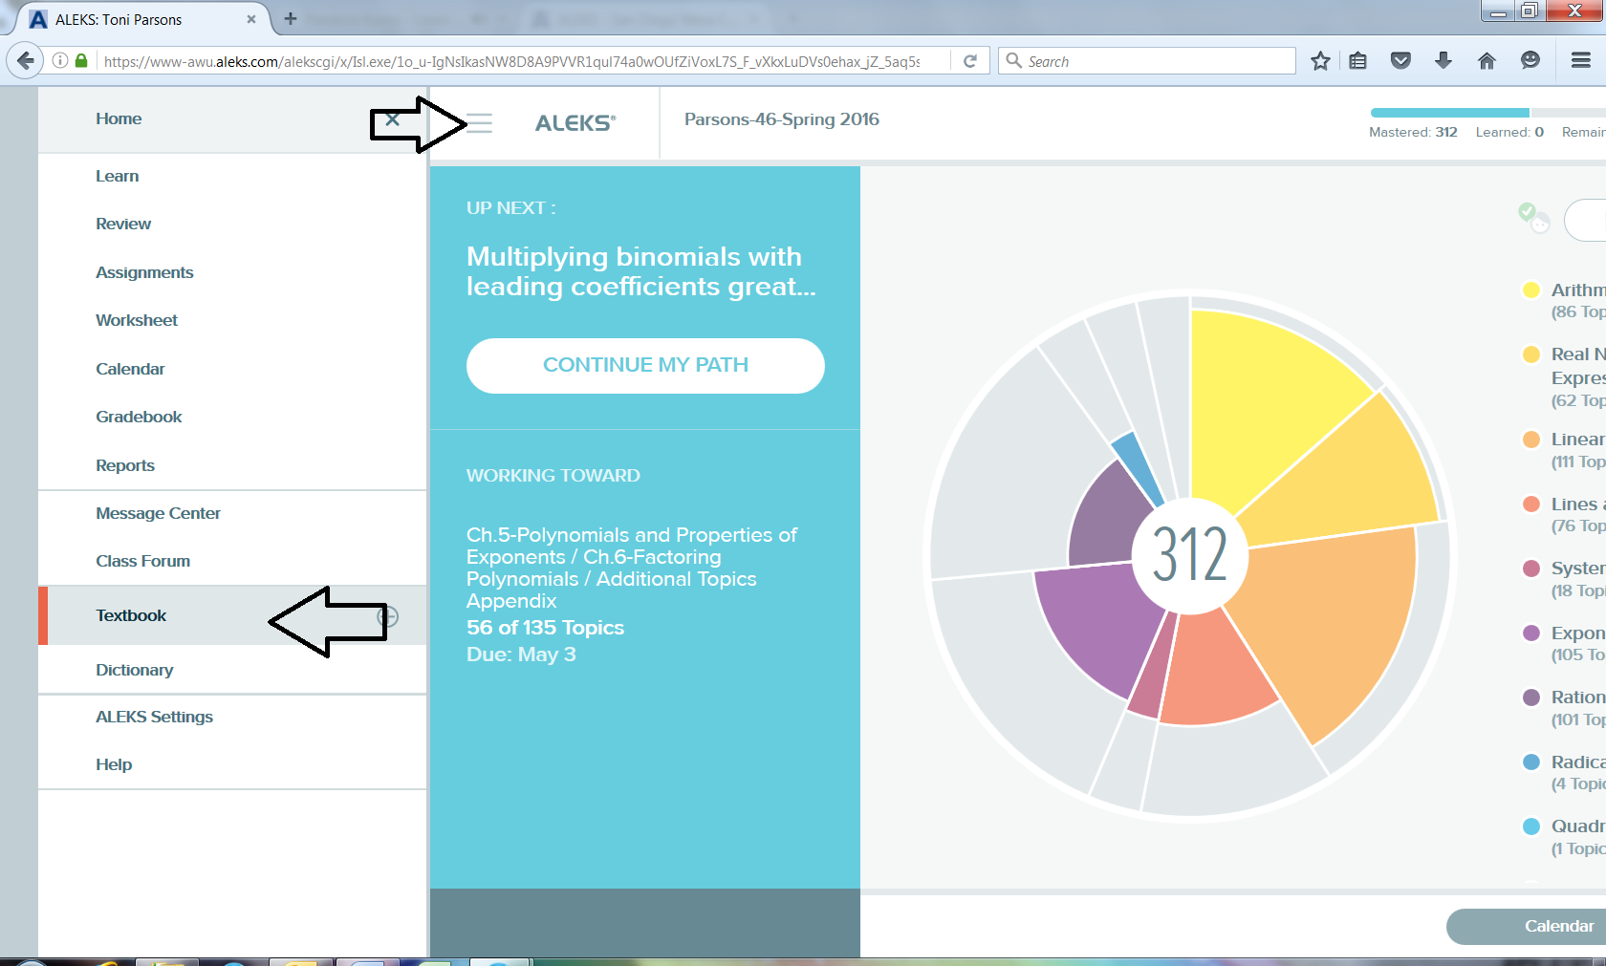

**How do I get started on my homework assignments?**

With ALEKS you will not have traditional homework assignments. Instead, your homework is to fill up the pie by the appropriate due dates. After you take a knowledge check, ALEKS will send you on your path. The easiest way to get through your homework is to “continue my path” in ALEKS. WARNING: Your path is set by your results on each knowledge check that you take. Therefore, you should take each one seriously as they pop up periodically.

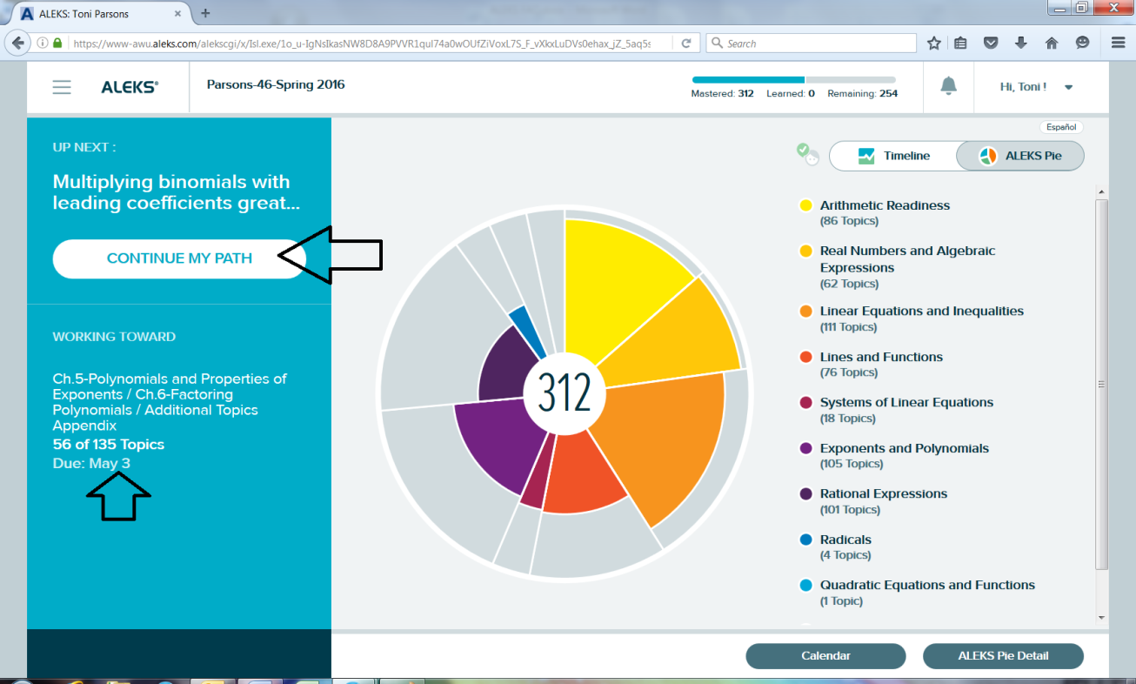

**Where do I find my grades in the program?**

You can find your grades under the three-bar menu button. You may want to ask your instructor how your grade on ALEKS is factored into your final grade.

**What helpful resources are available?**

* Every new topic you click on will start with a learning page which has an explanation of the problem and the solution.
* Depending on the textbook selected by your instructor, there are videos and other resources under the textbook tab.
* Your instructor can also add resources and link them to specific topics.
* The learning page also has links for videos, calculator, ebook, and message my instructor when available and appropriate.

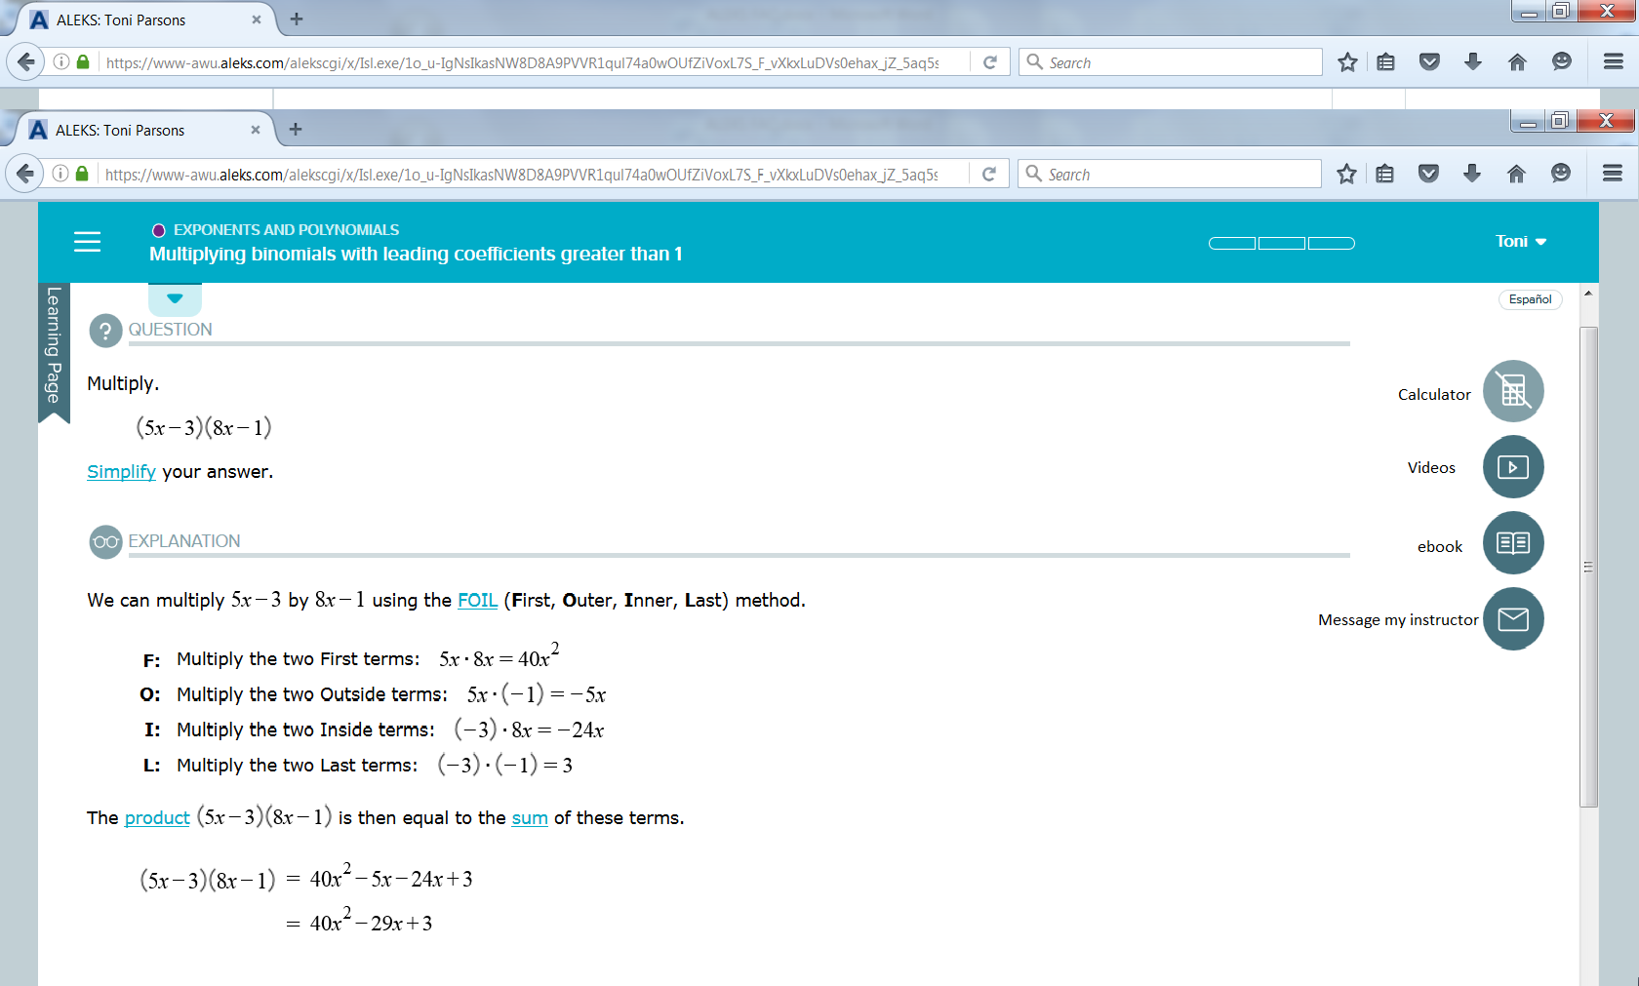

**How do I enter fractions/exponents/square roots/logarithms?**

When you need to enter an answer, an appropriate template will be available next to the answer box. These will change as appropriate for the problem.

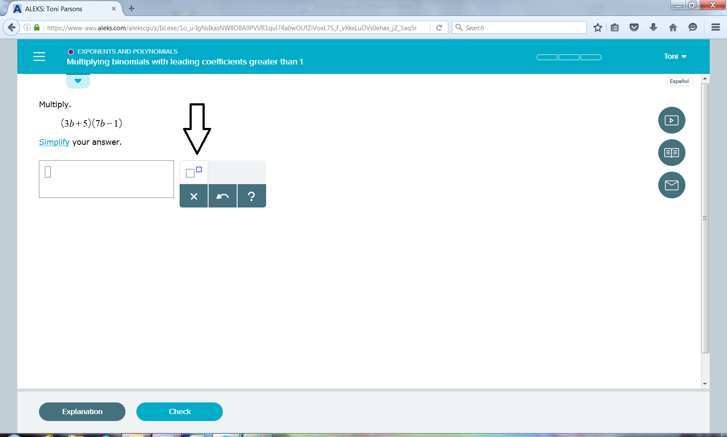

**Why did the program mark my answer wrong? I think it is correct.**

Students often overlook additional directions indicating how answers should be entered. Read all directions before entering an answer. Some of the more common errors are listed below.

* **Problems with Exponents** - Be sure to use the exponent button and use arrow keys to move out of the exponent as needed.
* You typed $x2+5$, but you probably meant $x^{2}+5$
* You typed $x^{2+2x-15}$, but you probably meant $x^{2}+2x-15$
* **Issues with Fractions -** Be sure to use the fraction button and use arrow keys to move up or down in the fraction
* You typed 5/8, but you probably meant $\frac{5}{8}$.
* You typed $5+\frac{\sqrt{12}}{14}$, but you probably meant $\frac{5 + \sqrt{12}}{14}$
* You typed 0.25, but the computer wanted a fraction.
* **Variable, including case** - Be sure to enter upper or lower case variable that match those given in the problem.
* You typed $3x^{2}+4x-7$, but you meant to type $3n^{2}+4n-7$
* You typed $6A+9$, but you probably meant $6a+9$
* **Exact vs. approximate answer** – The directions often ask for a specific format for answers.
* Exact answer: $12π$ Approximate answer: $37.68$
* Exact answer: $\sqrt{15}$ Approximate answer: $3.87$
* You will be marked wrong for improper rounding. Make sure you are rounding your answers only, not each intermediate step (unless otherwise instructed to).

**How do I graph a line?**

Use the pencil to plot two points. Then click on the line icon, line up your two points and click. NOTE: Every graph has the appropriate tools in the template and instructions on how to graph. This applies to lines, parabolas, etc.