**MyMathLab Frequently Asked Questions:**

* **Where Do I Start?**
* **Why Am I Having Problems Registering?**
* **Do I Have To Pay When I Register?**
* **How Do I Access My Textbook Through MyMathLab**
* **I’m Positive My Answer Is Correct. Why Is MyMathLab Counting It Wrong?**
* **What Is The Study Plan?**
* **What Are The Tutorial Features Of MyMathLab?**

**Where Do I Start?**

Just go to [www.mymathlab.com](http://www.mymathlab.com). Below Register Now click Student and then OK! Register Now.

Pearson has worked very hard to make student registration an easy process. Don’t panic. To register you need the following…

1.) Course ID – This is given to you by your professor.

2.) Access Code – This purchased from the bookstore.

OR

A Major Credit Card

**Why Am I Having Problems Registering?**

Pearson has worked very hard to make student registration an easy process. Don’t panic. To register you need the following…

1.) Course ID – This is given to you by your professor.

2.) Access Code – This purchased from the bookstore.

OR

A Major Credit Card

If, at any point, you get bogged down with an issue registering for your course go to…

Pearson 24/7 Technical Support

http://247pearsoned.custhelp.com/

**Do I Have To Pay When I Register?**

Actually, no! MyMathLab has a 14 day trial period. Select the 14-Day Trial option when you register. This is great for students who are not sure they will stay in the class. We strongly recommend you use the trials because once you pay, there are no refunds.

**How Do I Access My Textbook Through MyMathLab?**

There are actually several ways to access the textbook through MyMathLab. If you are doing homework online the easiest way is to access the book directly through the Help Menu on the homework pallet.

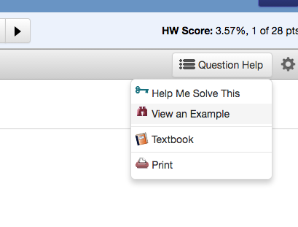

You can also access the textbook from the main tab bar in either “Chapter Contents” or “Multimedia Library”.

**I’m Positive My Answer Is Correct. Why Is MyMathLab Counting It Wrong?**

Here are the most common issues that result in answers that look correct but are not:

* When MyMathLab asks you to list all solutions and separate them with a coma, DO NOT put a space between the solutions.
* MyMathLab wants a particular form. Make sure you carefully read ALL the instructions for the problem. MyMathLab may be requesting a fraction, or a decimal rounded to a specified number of places.
* Always make sure to reduce fractions.
* Decimals rounded incorrectly or rounded to the wrong number of places.
* Rationalize denominastors. Most MyMathLab homework sets require you to rationalize denominators.

If you are absolutely sure that you have a correct answer and MyMathLab is still marking it wrong, DO NOT spend forever redoing the problem and trying to figure out why. Go into the “Gradebook” and “Review” the assignment, then make a printout of that question. The printout will have the “correct” along with your answer. Show the printout to your professor for guidance.

**What Is The Study Plan?**

The Study Plan is MyMathLab’s diagnostic component. “Diagnostic” means that the Study Plan will give you a quiz and use the results to make a custom assignment where you only study the types of problems you need work on.

To get started in the Study Plan go to the Study Plan tab and then click on “View all chapters”.

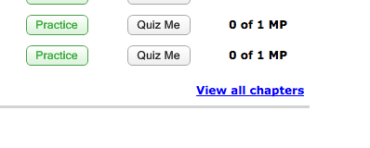

From there you can select the chapter you want to work on. Once you have selected the chapter then click “Quiz Me”.

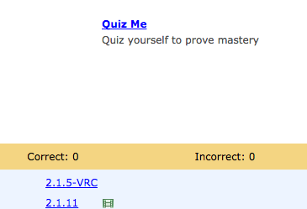

**What Are The Tutorial Features of MyMathLab?**

The tutorial features of MyMathLab are available in different parts of the program.

The actual homework screen contains three tutorial features under the Question Help menu.



* **Help Me Solve This** is an interactive tutorial feature. The program will take you step by step through the process of solving your exact exercise. As it moves through the steps it will ask you to enter to make sure you understand the process. Once you and the program have completed the problem together, the Help Me Solve This Window will close and the program will slightly change the numbers and/or variables in the problem so you try it on your own.
* **View An Example** also shows how the exercise is solved, but it is NOT interactive. That is, the program does not ask you to enter any part of the work.
* **Textbook** calls the e-text to the exact page where that topic is covered and where examples of that exercise are done.

MyMathLab has tutorial features aside from these in the homework screen. In fact, there are SO MANY tutorial features available in different parts of MyMathLab that Pearson created a menu tab where they can all be accessed from one place. That would be the one the Multimedia Library…

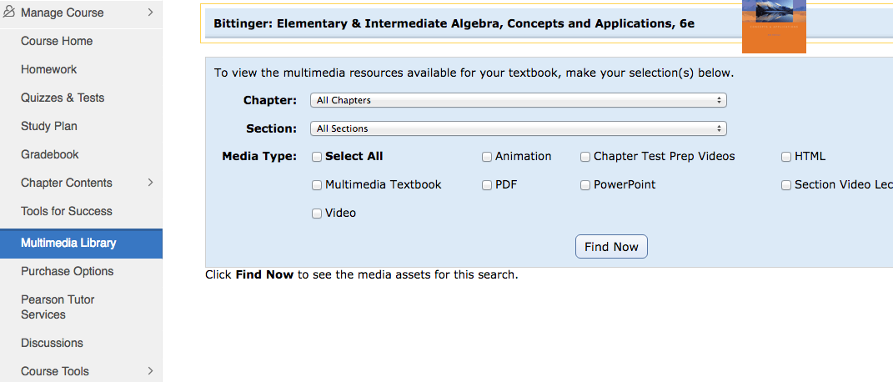

In Multimedia Library you can select a chapter and section and bring any number tutorial aids for that section. Probably the most important of these are the **Videos**. The videos provide a lecture style presentation of the material covered in a section. But notice that you can also access about seven other different learning aids from this tab.