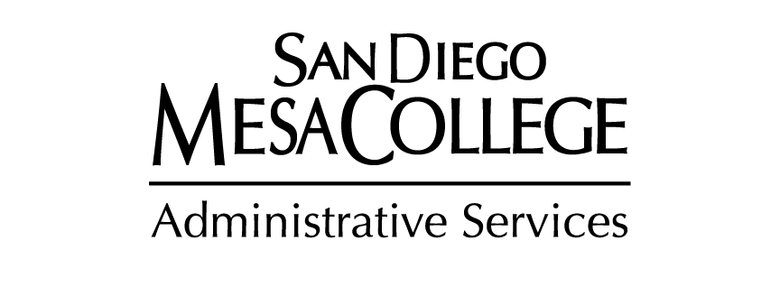

Colleagues,

As we enter the spring semester of this school year, the Administrative Services team would like to welcome our San Diego Mesa College family back for another excellent spring. We want to share some updates and information.

***Topics Include:***

* **Travel**
* **Purchasing Deadline**
* **Print and Mail**
* **College Technology**
* **Campus Safety Officer**
* **Facilities and Operations**

# **TRAVEL**

**Effective January 1, 2020**, the Internal Revenue Service (IRS) has changed the standard mileage rates for reimbursement, to 57.5 cents per mile.

With that in mind, the Business Services team has updated the Preauthorization Travel Form on Business Form page of their department site: <http://www.sdmesa.edu/college-services/administrative-services/forms/index.shtml> .

Please make sure that you are submitting the updated Preauthorization Travel Form for all future travel. As a reminder, the California Assembly Bill 1887 prohibits the use of State funds for travel to states that have discriminatory laws and/or practices of a serious nature that affect protected groups, especially the LGBTQ community. The list of banned states follows:

1. Alabama
2. Kansas
3. Kentucky
4. Mississippi
5. Oklahoma
6. North Carolina
7. South Dakota
8. Tennessee
9. Texas
10. South Carolina
11. Iowa

***If you have any questions regarding travel, please contact the Business Services Office at   
ext. 2771***.

# **Purchasing Deadlines**

As part of the annual year-end process, the campus and District are required to accurately classify all outstanding obligations. In order to accomplish this task, we have to establish year-end cut-off dates for various types of financial and budgetary transactions. Please see attached PDF for more information.

# **PRINT & MAIL**

For updated information such as hours and mail schedules, please be sure to visit the Print and mail website: <http://www.sdmesa.edu/college-services/administrative-services/print-mail-services/index.shtml>

# **COLLEGE TECHNOLOGY**

Please visit the Mesa College Technology Services - <http://www.sdmesa.edu/college-services/administrative-services/tech-support/> for information regarding the following items:

* **Mesa College Wireless/WiFi access code**
* **Student Printing information**
* **Employee hardware and software discount programs**
* **Canvas Support**
* **Help with classroom or laboratory technology equipment**
* **Help with your office computer/printer/telephone**
* **Report copier or pay-for-print system problems**
* **Installation or movement of classroom software or technology related equipment**
* **Podium key issuance or if you need your podium unlocked**
* **AV podium/smart classroom training and support**
* **Audio Visual equipment or help with Audio Visual system setup/training**
* **Scantron Locations**

*Note – Call us at 619-388-2880* **if you need immediate help** with classroom/laboratory technology.

# **CAMPUS SAFETY OFFICER**

As we enter the spring semester, we want to remind the Mesa College community that the occupational, environmental health, and safety programs fall under the Office of the Vice President of Administrative Services. The Vice President of Administrative Services, Lorenze Legaspi, is the campus wide Safety Officer.  Safety concerns may be reported to the Vice President of Administrative Services at any time via email, phone or by clicking [here](http://www.sdmesa.edu/college-services/safety/safety-form.shtml).

# **Facilities and OPERATIONS**

**K100 Renovation**

The K building Renovation work has begun. The first phase of the project, the rerouting of Information Technology services, is currently underway.  Once the technology reroute is complete renovations for The Resource Center, The Veterans Success Center and FAST Scholars will commence.  Renovations include new carpet, paint and furniture as well as office space for the faculty and staff. The entire project is slated to be complete for the fall 2020 semester start.

**D200 Renovation - Fermentation**

Our newest program, Fermentation, is preparing to be housed in D200. D205 received a much needed facelift and is ready for the first class of students. A classroom lab in D201, will be renovated during the spring semester with the first class running fall 2020.

**Quadrangle Renovation project**

The demolition of the I & J buildings is underway.  We expect the abatement to be finished by the end of February with the building demolition starting at the end of March, if not sooner.  Fencing has been erected around the buildings and surrounding areas as this is an active construction zone.

**Fuel Cell**

A single megawatt fuel cell is currently in the installation phase and is on target to be completed by the end of March 2020.  The installation of the fuel cell is phase II of our goal to reduce our carbon footprint, the solar panels installed on the Mesa Commons was phase I.  The intent of the fuel cell is that it will convert natural gas into electricity and in turn supply the campus with its average base load.

**Events**

The events arm of the campus is busy as usual.  We scheduled over 1000 events during the summer and fall semesters!! We made some changes to the events and reservations process. We are requesting you enter your requests no less than 2 weeks prior to your event so we can best support your needs.  Click [here](http://www.sdmesa.edu/college-services/administrative-services/event-planning/event-portal/documents/PortalEventandReservationFAQs.pdf) to review the event and reservation flow and FAQs.

**Wayfinding**

Additional signage and directional arrows will be placed throughout campus to ensure that members of the Mesa community can safely navigate campus during construction of the aforementioned projects.

**Ongoing Updates**

Please refer to your Facilities Planning Committee representative with questions or for updates on the above projects.