San Diego Mesa College

(insert Building name or number HERE)
Building Emergency Evacuation Plan

San Diego Mesa College

(Insert Building Name or Number HERE)
Building Emergency Evacuation Pan

Table of Contents

Introduction

In-House Emergency Team
- Emergency Evacuation Procedures
- Evacuation Maps
- Emergency Response Procedures
- Emergency Medical Procedures for Staff and Students
- Facilities: Locations of Emergency Systems

Emergency History Record

Locations Where This Plan is on File

Appendices
-Classroom Emergency Quick Guide
-Building Evacuation Observation Report
-Student Accident Report
-Telephone (bomb) Threat Report
-Building Occupancy List
-Important Personnel Contact List

Introduction
Scope:
This plan has been prepared to ensure orderly and complete evacuation of the (insert building name or number HERE) whenever an emergency occurs or the alarm sounds.

The primary objectives of this evacuation plan are:
- To ensure that everyone leaves the building safely.
- To develop and implement procedures to safely evacuate individuals who are injured or cannot negotiate stairs.
- To have a building occupancy accountability system in place to account for employees in the emergency evacuation zone.
- To have procedures for personnel, who are among building occupants, with defined functions to ensure the plan’s objectives can be achieved.

For the purpose of this plan, the following are considered emergencies for which a total or partial evacuation of the building is necessary:
- fire
- explosion
- chemical spill
- earthquake
- power outage
- bomb threat

The following emergency requires sheltering in place:
- active shooter

Emergency Notification:

(Review below to make sure alarm signals are the same for your building)

Building occupants are notified of emergencies through the use of the following signals and notifications:
- Fire alarm:
-sound: whooping electronic horn
-visual: strobe lights
- Announcements through building PA system
- word of mouth
- district/campus text messaging system

The plan will be evaluated and updated annually. An evacuation drill and/or table-top exercises should be conducted on an annual basis.
In-House Emergency Team

The in-house emergency team will consist of:
-The Emergency Facilitator, which will be the (Enter the Title or name of individual HERE). The Emergency Facilitator will be outside the building serving as the incident coordinator.
-The Floor Wardens (one primary for each floor, along with a designee for back-up purposes, totaling (enter number HERE)), which will assist in the orderly evacuation of the building and communicate information to the Emergency Facilitator.
-The Evacuation Area Coordinator, which will account for all evacuated building personnel.

Additional personnel will be assigned as needed.

PLEASE NOTE: Assigned duties are to be carried out only if you are not putting yourself in danger or risking your personal safety.

(Enter names and information BELLOW; adjust for # of floors in your building)
Name Office Ph. Cell Ph.
Emergency
Facilitator:
Designee

Floor Wardens:
Floor 1:
Designee:

Floor 2:
Designee:
Floor 3:
Designee:

Floor 4:
Designee:
Roof:
Evacuation Area Coordinator:
Primary:
Designee:

Other Assigned Personnel:

Building PA
Announcement: Administration and Faculty as Primary: Floor Wardens as Secondary

Responsibility of Emergency Facilitator:
- Collect information, from the Floor Wardens, on building occupants known or suspected to still be in the building.
- Meet emergency responders at building entrance.
- Report information on occupants needing assistance to evacuate and other personnel suspected to still be in building to emergency responders or Site Incident Commander (SIC).
- Transmit the All-Clear signal to Floor Wardens or other building emergency evacuation personnel.
- Transmit to the Evacuation Area Coordinator that people can be released from the evacuation zone and that it is ok to re-enter the building.
- Conduct post emergency meeting if necessary.
- Complete the Emergency History Report form. (located in the Appendix)

Emergency Facilitator’s Equipment:
- Flashlight
- Hand held FRS radio
- High-visibility vest
- Whistle
- Ear plugs (foam)
- Clipboard with all pertinent documents (Evacuation Plan, maps, phone contacts, etc.)
- Megaphone
- First aid kit

Responsibility of the Floor Wardens:
- Check all rooms including; labs, classrooms, restrooms, copier rooms, closets, etc., on the assigned floor to ensure they have been evacuated.
- Monitor corridors on assigned floor and ensure personnel are moving toward exits.
- Assist and/or direct all occupants to the emergency exits, as depicted on the evacuation map. If a disabled person is encountered, either assist them down the stairway or direct them to an area of refuge and notify Emergency Facilitator and/or emergency personnel.
- Make sure fire doors are closed and not blocked open.
- Leave the building as soon as possible and ensure assigned building entryways are being monitored.
- Report to the Emergency Facilitator, and/or directly to Fire Department, whether or not anyone is still within the building
- Prevent re-entry into the building until emergency responders or the Emergency Facilitator announces the all-clear signal.
- Fill out the building evacuation observation report form. (located in the Appendix)

Floor Warden’s Equipment:
- Flashlight
- Hand held FRS radio
- High-visibility vest
- Whistle
- Ear plugs (foam)
- Clipboard with all pertinent documents (Evacuation Plan, maps, phone contacts, etc.)
- Megaphone
- First aid kit

Responsibility of the Evacuation Area Coordinator:
- Check in all Faculty and Staff. (check-in sheet is in the appendix)
- Serve as communications liaison between the evacuation area and the Emergency Coordinator.
- Release Faculty, Staff and Students back into the building.
  - The release of people from the evacuation area will only occur when word is given by the Emergency Facilitator!
*NOTE: The Laboratory Technical Staff will be allowed entry back into the building before all other individuals.

Evacuation Area Coordinator’s Equipment:
- Flashlight
- Hand held FRS radio
- High-visibility vest
- Whistle
- Ear plugs (foam)
- Clipboard with all pertinent documents (Evacuation Plan, maps, phone contacts, building occupancy list etc.)
- Megaphone
- First aid kit

Emergency Evacuation Procedures

Employee Evacuation Procedure:
In advance, each Staff and Faculty member should:
1. Read and understand the evacuation plan.
2. Recognize the sound of the evacuation alarm.
3. Know at least two ways out of the building from your regular work space.

When you hear the evacuation alarm or are told to evacuate the building:
- Remain calm.
- Immediately shut down any hazardous operations. A hazardous operation is anything that can contribute to or increase the dangers of an emergency by being left unattended.
- Everyone must exit the building, regardless of the reason the alarm sounded (real, accidental, or drill). DO NOT IGNORE THE ALARM!
- Do NOT use elevators during an active alarm; only use the designated stairways.
- Classes in session must be dismissed, with Faculty and Students exiting to the designated evacuation area/assembly point.
- Take with you: your car keys, purse, briefcase, etc. However do not attempt to take large or heavy objects.
- As you are exiting the building, advise and direct any other people to exit the building.
- If someone absolutely refuses to leave the building, note their location, continue to exit the building and inform the Floor Warden, Emergency Facilitator and/or Emergency Responders of his/her location.
- Assist or accompany anyone who is immobile or physically impaired, if you are unable to assist, note their location and disability, exit the building and inform the Floor Warden, Emergency Facilitator and/or Emergency Responders of his/her location.
- Shut all doors behind you as you go. Closed doors can slow the spread of fire, smoke, and water.
- The Floor Warden, or other assigned person, is responsible for insuring all individuals on their respective floor have evacuated. However, employees should check their work areas to make sure that all others are leaving as instructed.

Once you have exited the building:

- Do not go back into the building for any reason.
- Proceed to the designated emergency evacuation assembly point and check in with the Evacuation Area Coordinator. If the designated assembly point/area is unsafe or blocked due to the emergency, proceed to an alternate assembly point.
Remember it is each Staff and Faculty member’s responsibility to check in!
- Return to the building only after emergency officials or building monitors give the all-clear signal. Silencing of the Alarm doesn’t mean the emergency is over.

Reentering the Building:

Once the all clear is given by the emergency personnel, the Emergency Facilitator will notify the laboratory staff and they will be the first to be allowed back into the building. The laboratory staff will make sure that doors into sensitive areas are secure and that all rooms are safe to reenter. The Emergency Facilitator will then communicate to the Evacuation Area Coordinator that the all clear has been given and the faculty and students will then be released from the evacuation area and allowed to reenter the building.

The building will be evacuated for the following conditions:
- fire
- explosion
- chemical spill
- earthquake
- power outage
- bomb threat

The following emergency requires sheltering in place:
- active shooter

Evacuation Procedures for People with Disabilities:
The following guidelines should be considered when assisting persons with disabilities in an evacuation. Staff and Faculty should familiarize themselves with these procedures.

FIRST:
Communicate the nature of the emergency to the person.
SECOND:
Ask the person how they would like to be assisted.
THIRD:
If the person is using mobility aids, evacuate them with the person if possible.

Keep the following information in mind when assisting persons with a disability:

Visually Impaired Persons:
In the event of an emergency or building evacuation, tell the person what the nature of the emergency is and offer to guide him/her to the nearest exit. Have the person take your elbow and escort him/her (this is the proper method when acting as a “sighted guide”) advising of any obstacles, such as stairs, narrow passageways or overhanging objects. When you have reached safety, orient the person to where he/she is and ask if further assistance is needed.

Hearing Impaired Persons:
To warn an individual of an emergency, it is best to get the person’s attention with a gesture or a light tap on the arm or shoulder. Either write a note telling the individual what the emergency is and the nearest evacuation route, or use simple gestures to indicate that the person should come with you. An example of a note would be: “Fire—go out back door, turn right and go down and exit the building now!” It is always best to personally escort people with disabilities from the building.

To warn a group of hearing impaired individuals, try and get the group’s attention by flashing the room lights on and off – then gesture to indicate that the group should come with you. If there is a whiteboard write a note, so that all can see, indicating what the emergency is.

Persons Using Crutches, Canes, or Walkers:
Ask the person what method of assistance they prefer. Check for the availability of an evacuation chair and always evacuate mobility aids with the person if possible. If an evacuation chair is not available, other carry methods include: the two-handed seat, four –handed seat, human crutch.
Persons Using Wheelchairs:
A person in a wheelchair may have a preference to the type of assistance and/or the method in which they are moved. Make sure that the individual is asked what type of assistance they prefer. Some people have minimal ability to move and lifting them may be dangerous to their well-being. In addition some people using wheelchairs have respiratory complications; it is important to remove them from smoke or fumes immediately.
If the person wants to be moved in their wheelchair, keep the following in mind:
- They should be moved down stairs in a forward facing position.
- Two people should assist on a staircase; one in the back and one in the front. If possible, a third person should act as a “spotter”.
- Wheelchairs have many moveable or weak parts.
- Some people have no upper trunk or neck strength, so move them with caution.
- Power wheelchairs have heavy batteries; an evacuation chair may be needed and the wheelchair retrieved later.
- A seat belt should be used, if available.
- Remember, in the event of an emergency the elevators will not be a viable option to move an individual that is in a wheelchair.
If the person prefers to be removed from the wheelchair for evacuation, ask for the individuals’ preference on the following:
- Ways of being removed from the wheelchair.
- Whether to move extremities or not.
- Being moved forward or backwards down stairs.
- Whether a seat cushion or pad should be brought.
- What is necessary for aftercare.
If you have moved a person in a wheelchair, note the location of the wheelchair or mobility aids, so that they may be retrieved as soon as possible.
If an evacuation chair is to be used make sure the directions are read and followed to avoid injuries to the individual and yourself.
Evacuation chairs are located throughout the building and can be found at the following locations: (Enter location of evac chairs BELOW, if applicable. Or you can delete this section)
Second floor (1 chair) -

Third floor (2 chairs) -

Fourth floor (2 chairs) -

Fifth floor/Roof (1 chair) –
(The next section should contain evacuation maps. EXAMPLE maps have been left in to so you what your maps might look like)
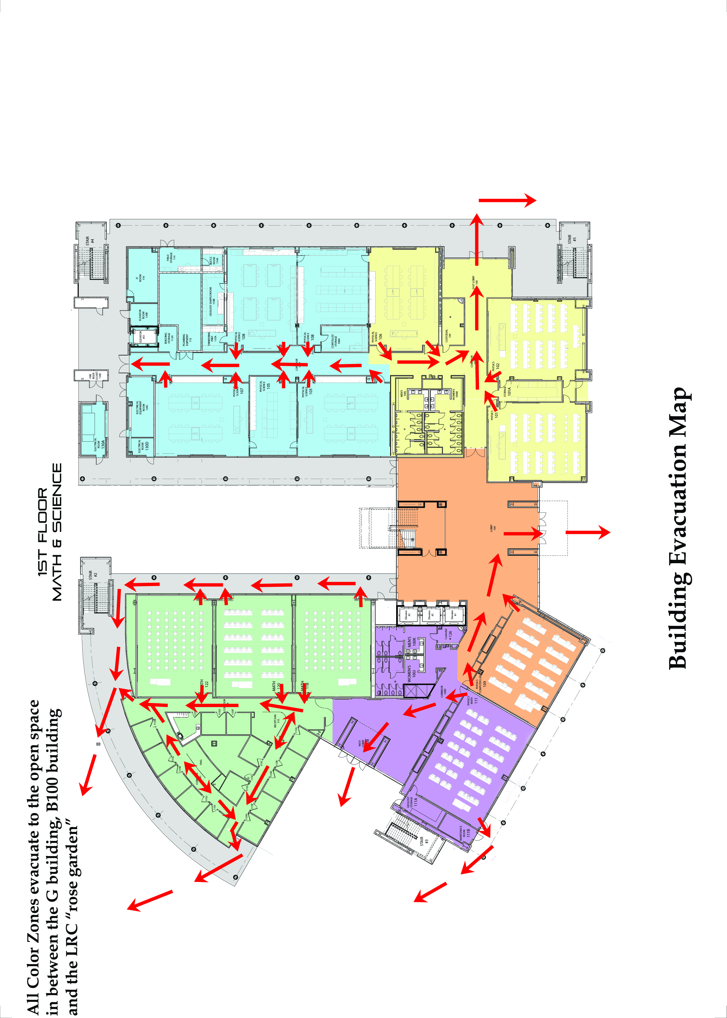

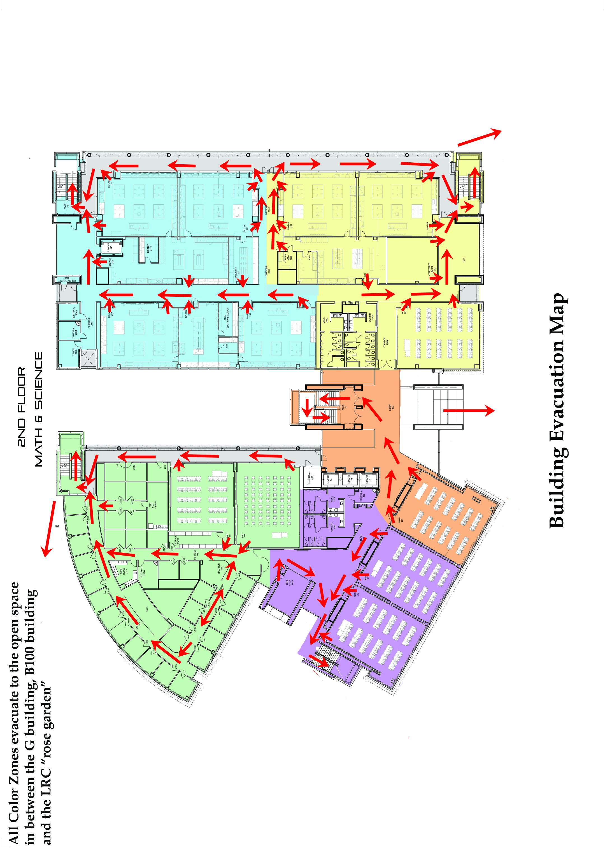
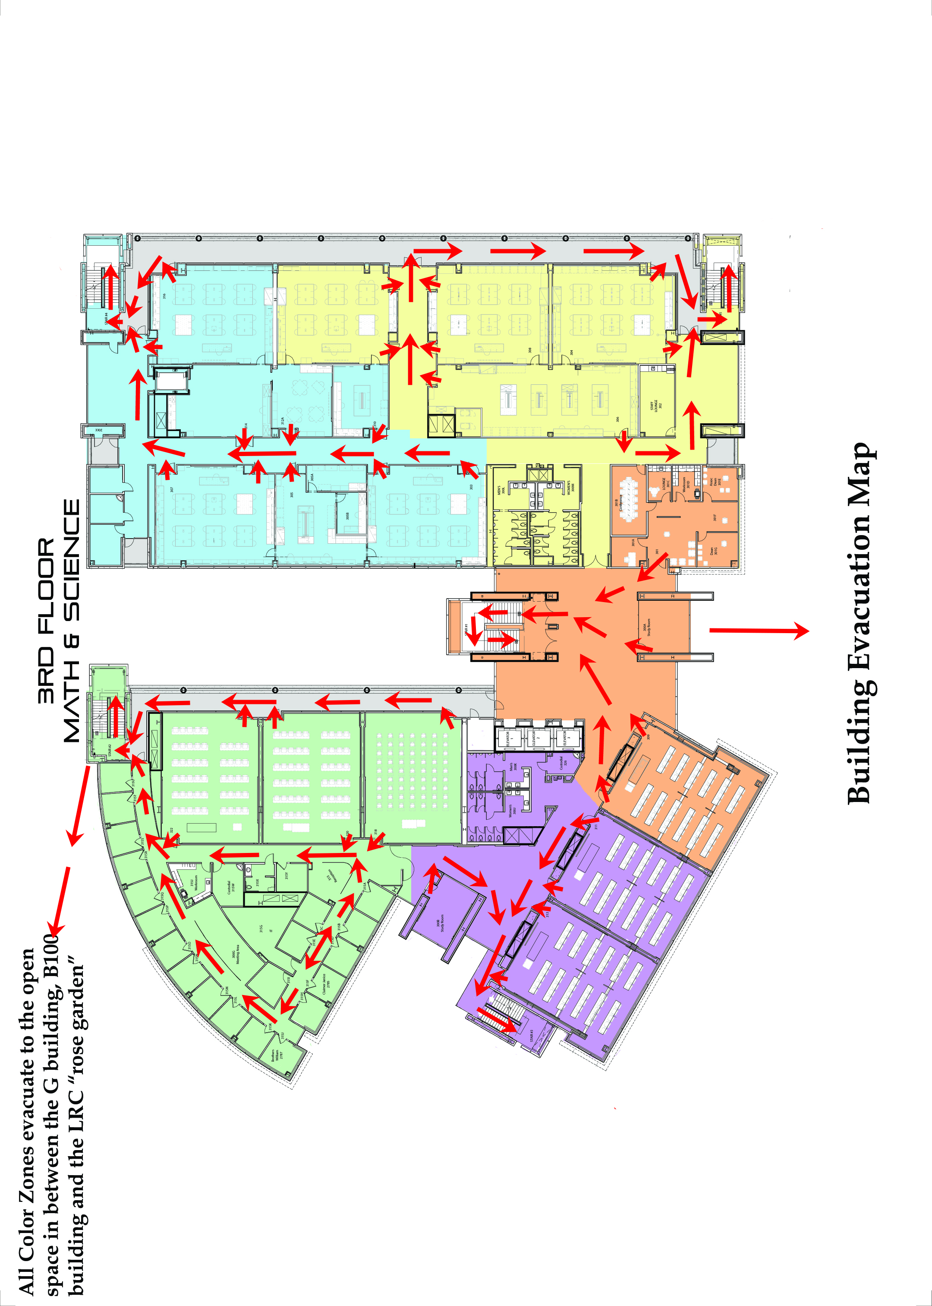
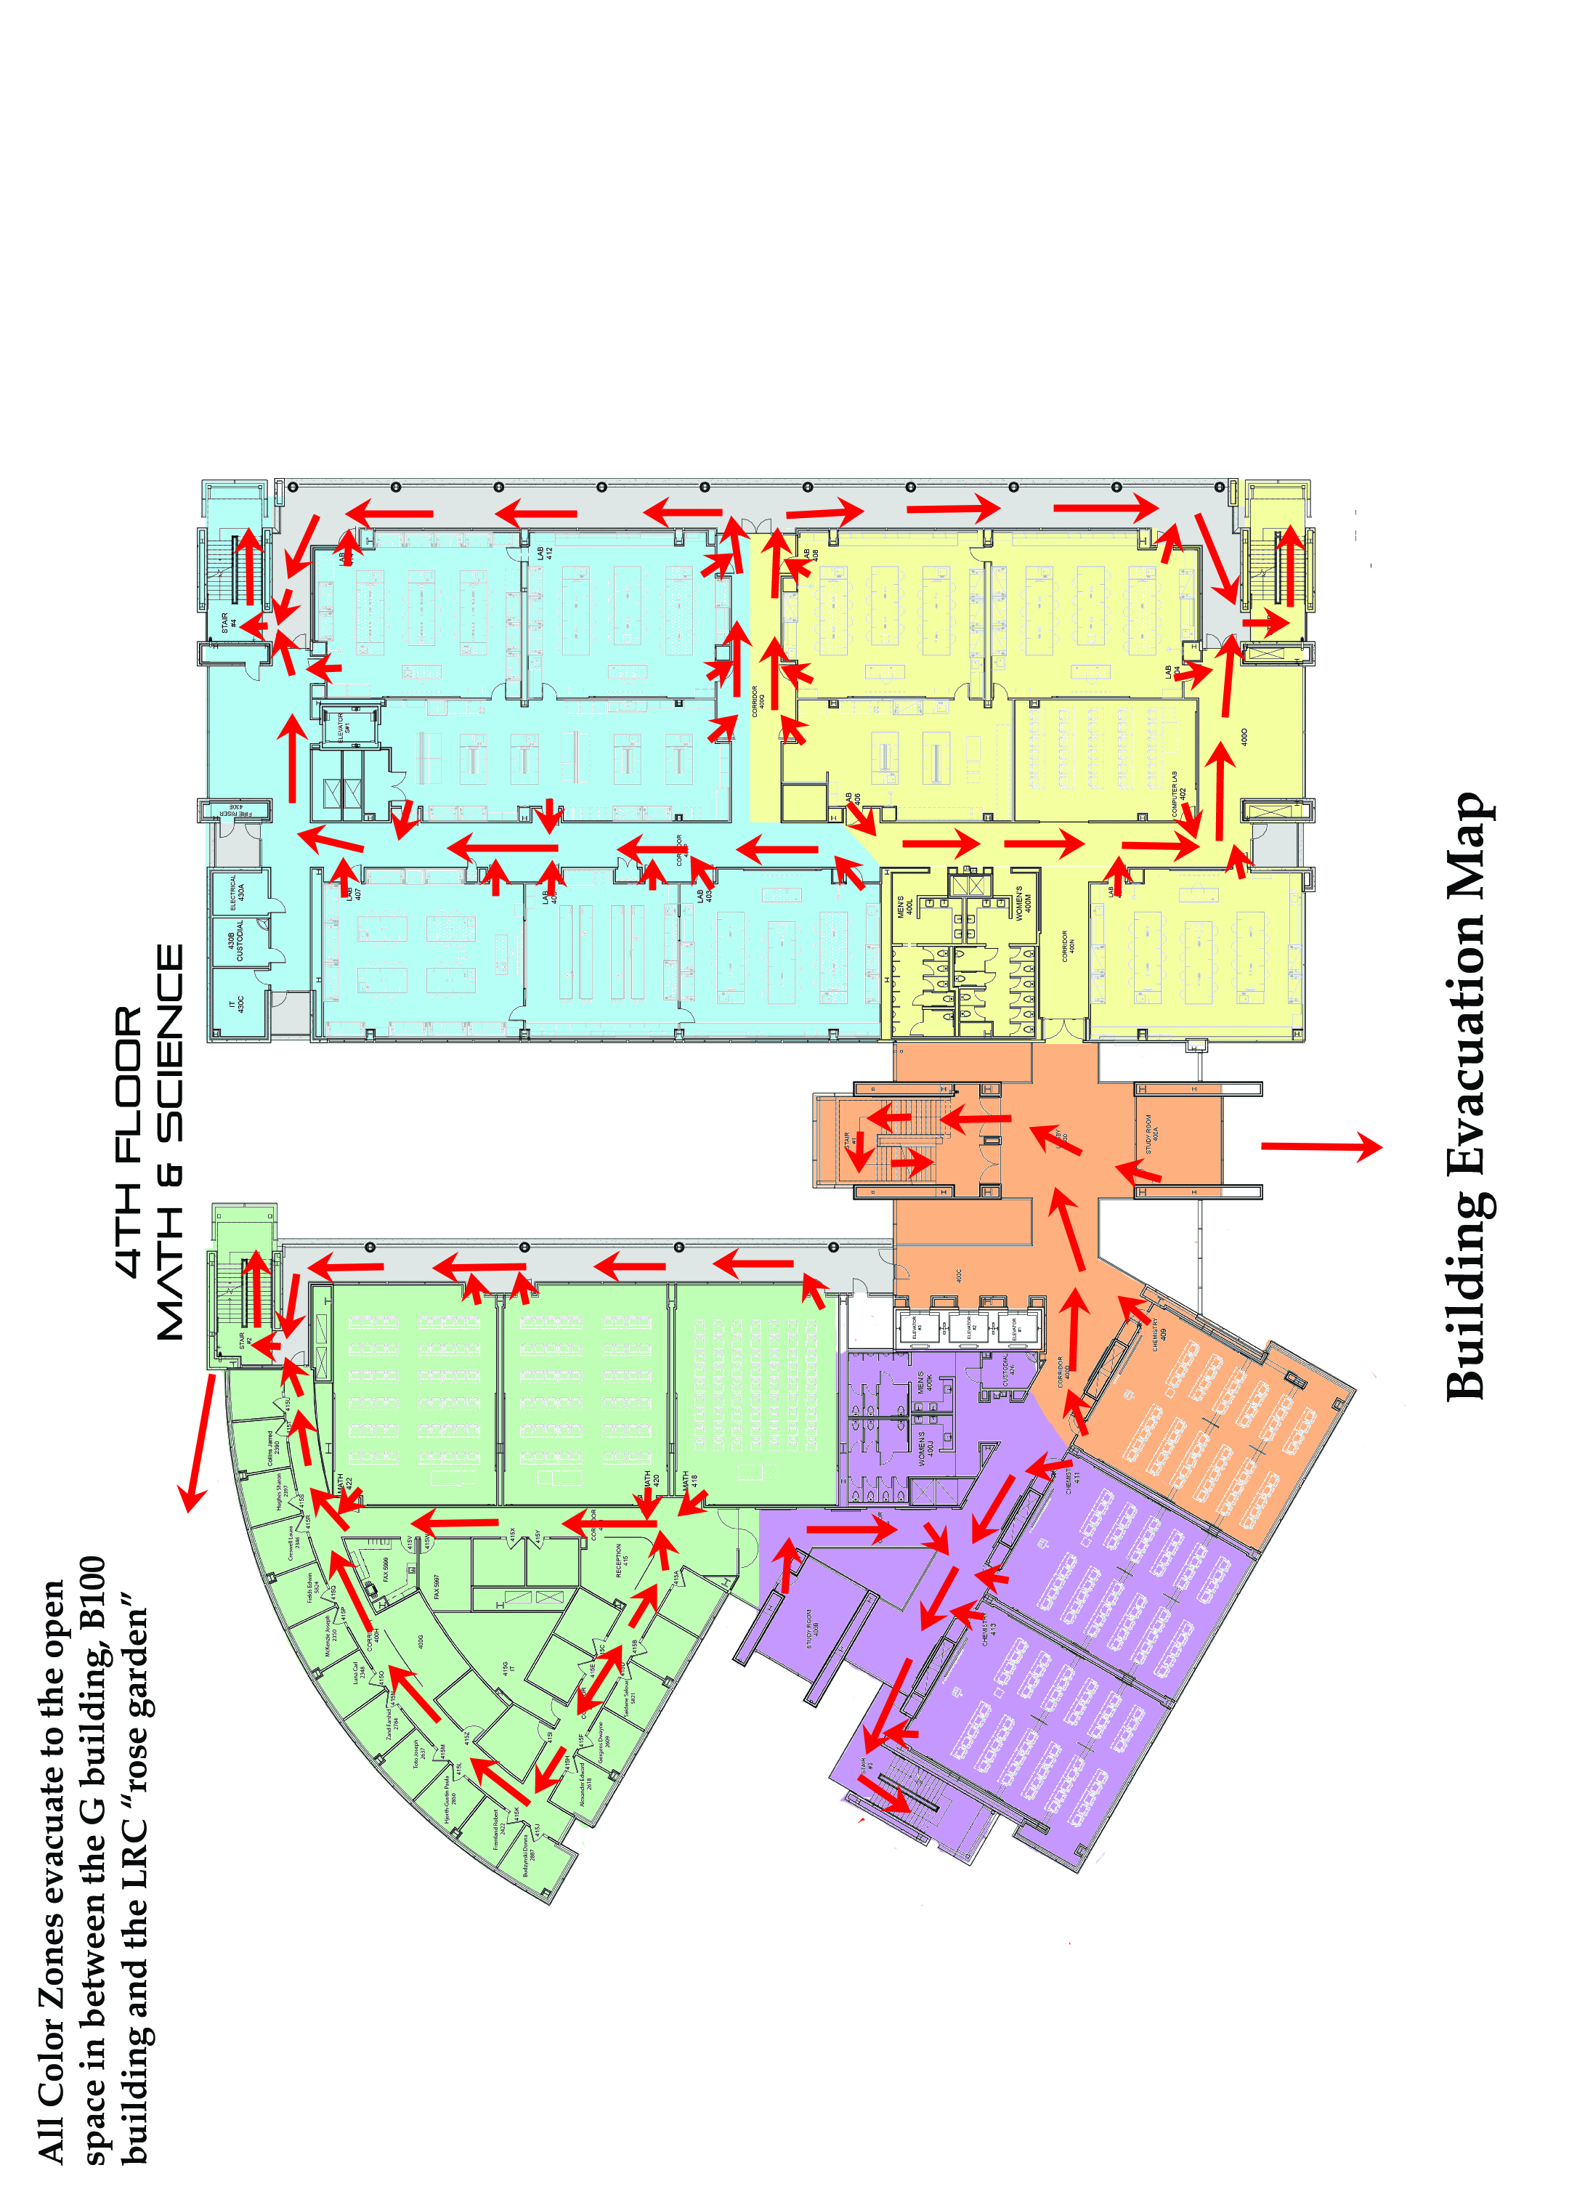
Emergency Response Procedures

Immediate Incident Response
- Assess your own safety and act accordingly.
- Act to protect lives first, then physical property.
- If needed, ask for help from a co-worker or another person in the area.

MAKE THE FOLLOWING PHONE CALLS in the order of priority shown, based on the type of incident.

First calls made:
TYPE OF INCIDENT: | WHO TO CALL:
Fire  (if larger than a fire extinguisher can handle) | Campus Police Dispatch  619-388-6405  And/or  Fire Department  9-911
People Hurt  (*Serious injury requiring more than basic first aid) | Campus Police Dispatch  619-388-6405  And/or  Fire Department  9-911
Structure or Utility Damage  (building, equipment, water, or electrical) | Facilities Call Center  x6422

Second calls made:
TYPE OF INCIDENT: | WHO TO CALL:
All emergencies  during working hours | (enter name or position HERE, should be a Dean or Supervisor)
All emergencies  after working hours  (approx. 5pm) | Campus Police Dispatch  619-388-6405

*Serious injuries would include the following: death, amputation, concussion, loss of consciousness, heart attack, stroke, crushing (internal injuries), fracture, burn, laceration requiring stiches or having significant bleeding.

Calls should be made for all indicated incidents. For injuries to either students or staff complete the appropriate form (see Appendix) and send it to your supervisor.

The following are emergency procedures for specific types of incidences:

Fire:
If a fire occurs in your area or the alarm is activated:
- Remain calm.
- If needed, Call campus police x6405, or push the button on the red emergency box, or dial 911.
- If the fire is small, attempt to put it out with a fire extinguisher. Do not jeopardize your personal safety.
- Never allow the fire to come between you and an exit.
- Disconnect electrical equipment that is on fire if it is safe to do so (pull the plug or throw the circuit breaker) or perform any emergency shutdown procedures.
- Evacuate your area if you are unable to put out the fire. Close doors and windows behind you to confine the fire. Go to a designated area (see map).
- Notify your supervisor of the location and extent of the fire.
- Do not break windows. Oxygen feeds a fire.
- Do not open hot doors. Before opening any door, touch near the top. If the door is hot or if smoke is visible, do not open the door.
- Do not use elevators during an evacuation.
- Do not attempt to save possessions at the risk of personal injury.
- Do not return to the area until cleared by emergency personnel.
All fires, no matter how small, must be reported to a supervisor.

Explosion:
- Remain calm.
- Be prepared for possible further explosions.
- If needed, Call campus police x6405, or push the button on the red emergency box, or dial 911.
- Crawl under a table or desk.
- Stay away from windows, mirrors, overhead fixtures, filing cabinets, bookcases, and electrical equipment.
- If an evacuation is ordered, go to the designated area (see map).
- Do not move seriously injured persons unless they are in obvious, immediate danger (of fire, building collapse, etc.).
- Inform the Emergency Facilitator, Floor Warden, or Emergency Responders of the materials involved in the explosion, if known.
- Open doors carefully. Watch for falling objects.
- Do not use elevators.
- Do not use matches or lighters.
- Avoid using telephones.
- Do not spread rumors.

Chemical Events; Spills and Fires:
If a chemical spill occurs within the building:
- If toxic chemicals come in contact with your skin, immediately flush the affected area with clean water. Use chemical shower if available.
- Notify your supervisor of the extent and location of the spill.
- If there is any possible danger, evacuate your area and contact the school Administrator.

If a chemical fire occurs within the building:
- Remain calm.
- If needed, Call campus police x6405, or push the button on the red emergency box, or dial 911.
- If the fire is small, attempt to put it out with a chemical fire extinguisher. Do not jeopardize your personal safety.
- Never allow the fire to come between you and an exit.
- Notify your supervisor of the location and extent of the fire.
- Evacuate your area if you are unable to put out the fire. Close doors and windows behind you to confine the fire. Go to a designated area (see map).
- Do not break windows. Oxygen feeds a fire.
- Do not attempt to save possessions at the risk of personal injury.
- Do not return to the area until cleared by emergency personnel.
All chemical spills and fires, no matter how small, must be reported to a supervisor.

Earthquake:
In the event of an earthquake:
- Remain calm.
- Stay in the building. DROP, COVER, AND HOLD! Immediately drop to the floor and take cover under a sturdy piece of furniture like a strong desk or table, try to make yourself as small as you can to avoid having debris fall on top of you.
- Stay away from windows, mirrors, overhead fixtures, filing cabinets, bookcases, and electrical equipment
- Do not attempt to leave the building while the earthquake is happening, as there could be falling debris, shattering glass, exit stairwells may have collapsed or be jammed with people.

After the earthquake has stopped:
- Remain alert for aftershocks.
- Assist those who have been trapped or injured by falling debris, glass, etc. Do not move seriously injured persons unless they are in obvious, immediate danger (of fire, building collapse, etc.).
- Evacuate the building if safe to do so. Do not re-enter until the building has been declared structurally sound.
- Once evacuated go to the designated evacuation point (see map).
- Listen to local radio stations for instructions.
- Do not use the telephone, except in a real emergency. The lines should be kept free for emergency rescue operations.

Power Outage:
If a power outage occurs:
- Remain calm.
- Provide assistance to visitors and staff in your immediate area.
- If you are in an unlighted area, proceed cautiously to an area that has emergency lights.
- If you are in an elevator, stay calm. Use the intercom or the emergency button to notify building security.
- If instructed to evacuate, go to the designated area (see map).
- Secure the building from vandalism, intrusion, and fire.

Bomb Threat, Phone Threat, Mail Threat, or Suspicious Object:
If you receive a telephone threat:
- Remain calm.
- Record the phone number that appears on the phones caller ID system.
- Listen carefully. Be polite and show interest. Try to keep the caller talking so you can gather more information.
- If possible, signal a colleague to inform administration for you or call yourself as soon as the caller hangs up.
- Call Campus Police at x6405.
- Promptly complete a telephone threat report, writing down as many details as you can remember. This information will be needed by the police interviewers.
- Do not discuss the threat with other staff.
- If evacuation is ordered, go to a designated area (see map).

If you receive a written threat or a suspicious package or if you find a suspicious object anywhere on the premises:
- Keep anyone from handling it or going near it.
- Notify your supervisor immediately.
- Call the police.
- Promptly write down everything you can remember about receiving the letter or package, or finding the object. This information will be needed by the police interviewers.
- Remain calm. Do not discuss the threat with other staff members.
- If evacuation is ordered, go to the designated area (see map).

Active Shooter:
When there is an active shooter in the building, follow these procedures.
First and foremost RUN.
- If you can get out, do; always try to escape or evacuate.
- Encourage others to come with you, but do not let others slow you down with indecision.
- Leave belongings behind
- Once outside of the building and out of the line of fire call 911. Try to prevent others from entering the danger zone.

If you cannot get out safely you need to HIDE.
- Act quickly and quietly and secure the room you’re in the best you can.
- Lock the door.
- Turn out lights.
- Turn off your cell phone’s ringer and vibrate mode.
- Hide behind large objects.
- Remain quiet and calm.

The hiding place should (be):
-out of sight.
-provide protection if shots are fired.
-not trap or restrict your option for movement.

As a last resort, and only if your life is at risk, FIGHT.
- Act with aggression.
- Attempt to incapacitate the shooter.
- Improvise weapons.
- COMMIT to your actions.

If there is an active shooter on Campus, all buildings should go into lockdown.
- Everyone in hallways or open areas is to seek shelter in the nearest room.
- Lock and barricade doors.
- Close windows and window treatments.
- Turn off lights.
- Everyone is to remain quiet (quietly contact 911) and do not enter hallways or open areas.
- Crouch down in areas that are out of sight from doors and windows.
- Should the fire alarm sound, do not evacuate the building unless:
  - -You have firsthand knowledge that there is a fire in the building, or
  - -You have been advised by Police/Security to evacuate the building, or
  - -There is imminent danger in the immediate area.
- Do not leave the classroom or office until there is an announcement by the building administrator (or designee) and/or the police.

Emergency Medical Procedures for Staff and Students:

Medical Emergencies: Staff
If a staff member or volunteer is seriously ill or injured:

            - Notify your supervisor immediately.

            - If needed, Call campus police x6405, or push the button on the red emergency box, or dial 911.

            - Render the minimum first aid necessary and decide what additional treatment is required (call Fire Department, paramedics, ambulance, other).

            - Do not attempt to move a person who has fallen and who appears to be in pain.

            - Avoid unnecessary conversation with or about the ill or injured person. You might add to the person's distress or fears, increasing the risk of medical shock. Limit your conversation to quiet reassurances.

            - After the person has been taken care of and the incident is over, remain available to help the supervisor with pertinent information for a medical report or, if applicable, a Workers' Compensation report.

            - Contact Personnel for any questions concerning Workers' Compensation.

Medical Emergencies: Students
When an employee observes a student or visitor who appears to be ill or injured:

- Notify your supervisor immediately.

- If needed, Call campus police x6405, or push the button on the red emergency box, or dial 911.

- Render the minimum first aid necessary and decide what additional treatment is required (call Fire Department, paramedics, ambulance, other).

- Do not attempt to move a person who has fallen and who appears to be in pain.

- Avoid unnecessary conversation with or about the ill or injured person or members of his/her party. You might add to the person's distress or fears, increasing the risk of medical shock. Limit your conversation to quiet reassurances.

- Do not discuss the possible causes of an accident or any conditions that may have contributed to the cause.

- Under no circumstances should an employee or volunteer discuss any insurance information with members of the public.

- After the person has been taken care of and the incident is over, remain available to help the supervisor with pertinent information for a Student Accident Report. (see Appendix)

Facilities: Locations of Emergency Systems

Building: Enter building name or number HERE

A. Main Utilities
1. Main water shut-off valve: Put information HERE
2. Sprinkler shut-off valve: Put information HERE.
3. Main electrical cut-off switch: Put information HERE.
4. Main gas shut-off: Put information HERE.
5. Heating/cooling system controls: Put information HERE.
6. Main outside Fire Department connection/standpipe: Put information HERE.

B. Fire Suppression Systems (by room or area)
1. Fire extinguishers: Put information HERE
*EXAMPLE*
See attached maps of each floor. Each Laboratory and Prep room has an ABC fire extinguisher and there are several scattered about through the classroom and office wing of the building.

2. Fire hoses: Put information HERE or delete this section if not applicable
*EXAMPLE*
There are fire risers/standpipes on each floor near the stairwell landing. There are also fire risers located on each floor landings of the external staircases.

There are also several fire risers/standpipes on the roof of the building.

E. Fire Extinguishers (See Map)
Put information HERE
*EXAMPLE*
At this point in time there are only Type ABC – combination extinguishers located in the building.

F. Fire Alarm Pull Boxes (see floor plan)
Put information HERE
*EXAMPLE*
All pull boxes are on the first floor at each exit of the building and near the two elevators on the roof.

I. First Aid Kits
Put information HERE

J. AED
Put information HERE

K. Evacuation Chairs
Put information HERE or delete this section if not applicable
*EXAMPLE*

Second floor (1 chair) - Room 200G (faculty office wing).

Third floor (2 chairs) - Room 300G (faculty office wing) and Hallway in between building Staircase 1 (central staircase) and the laboratory wing.

Fourth floor (2 chairs) - Room 400G (faculty office wing) and Hallway in between building Staircase 1 (central staircase) and the laboratory wing.

Fifth floor/Roof (1 chair) - On the landing of the central staircase 1.

L. Public Address System Put information HERE or delete this section if not applicable
Authorized Personnel:

(The next section should contain maps that show where emergency service items are located such as; alarm pulls, fire extinguishers, AED’s, and other items. EXAMPLE maps have been left in to so you what your maps might look like)

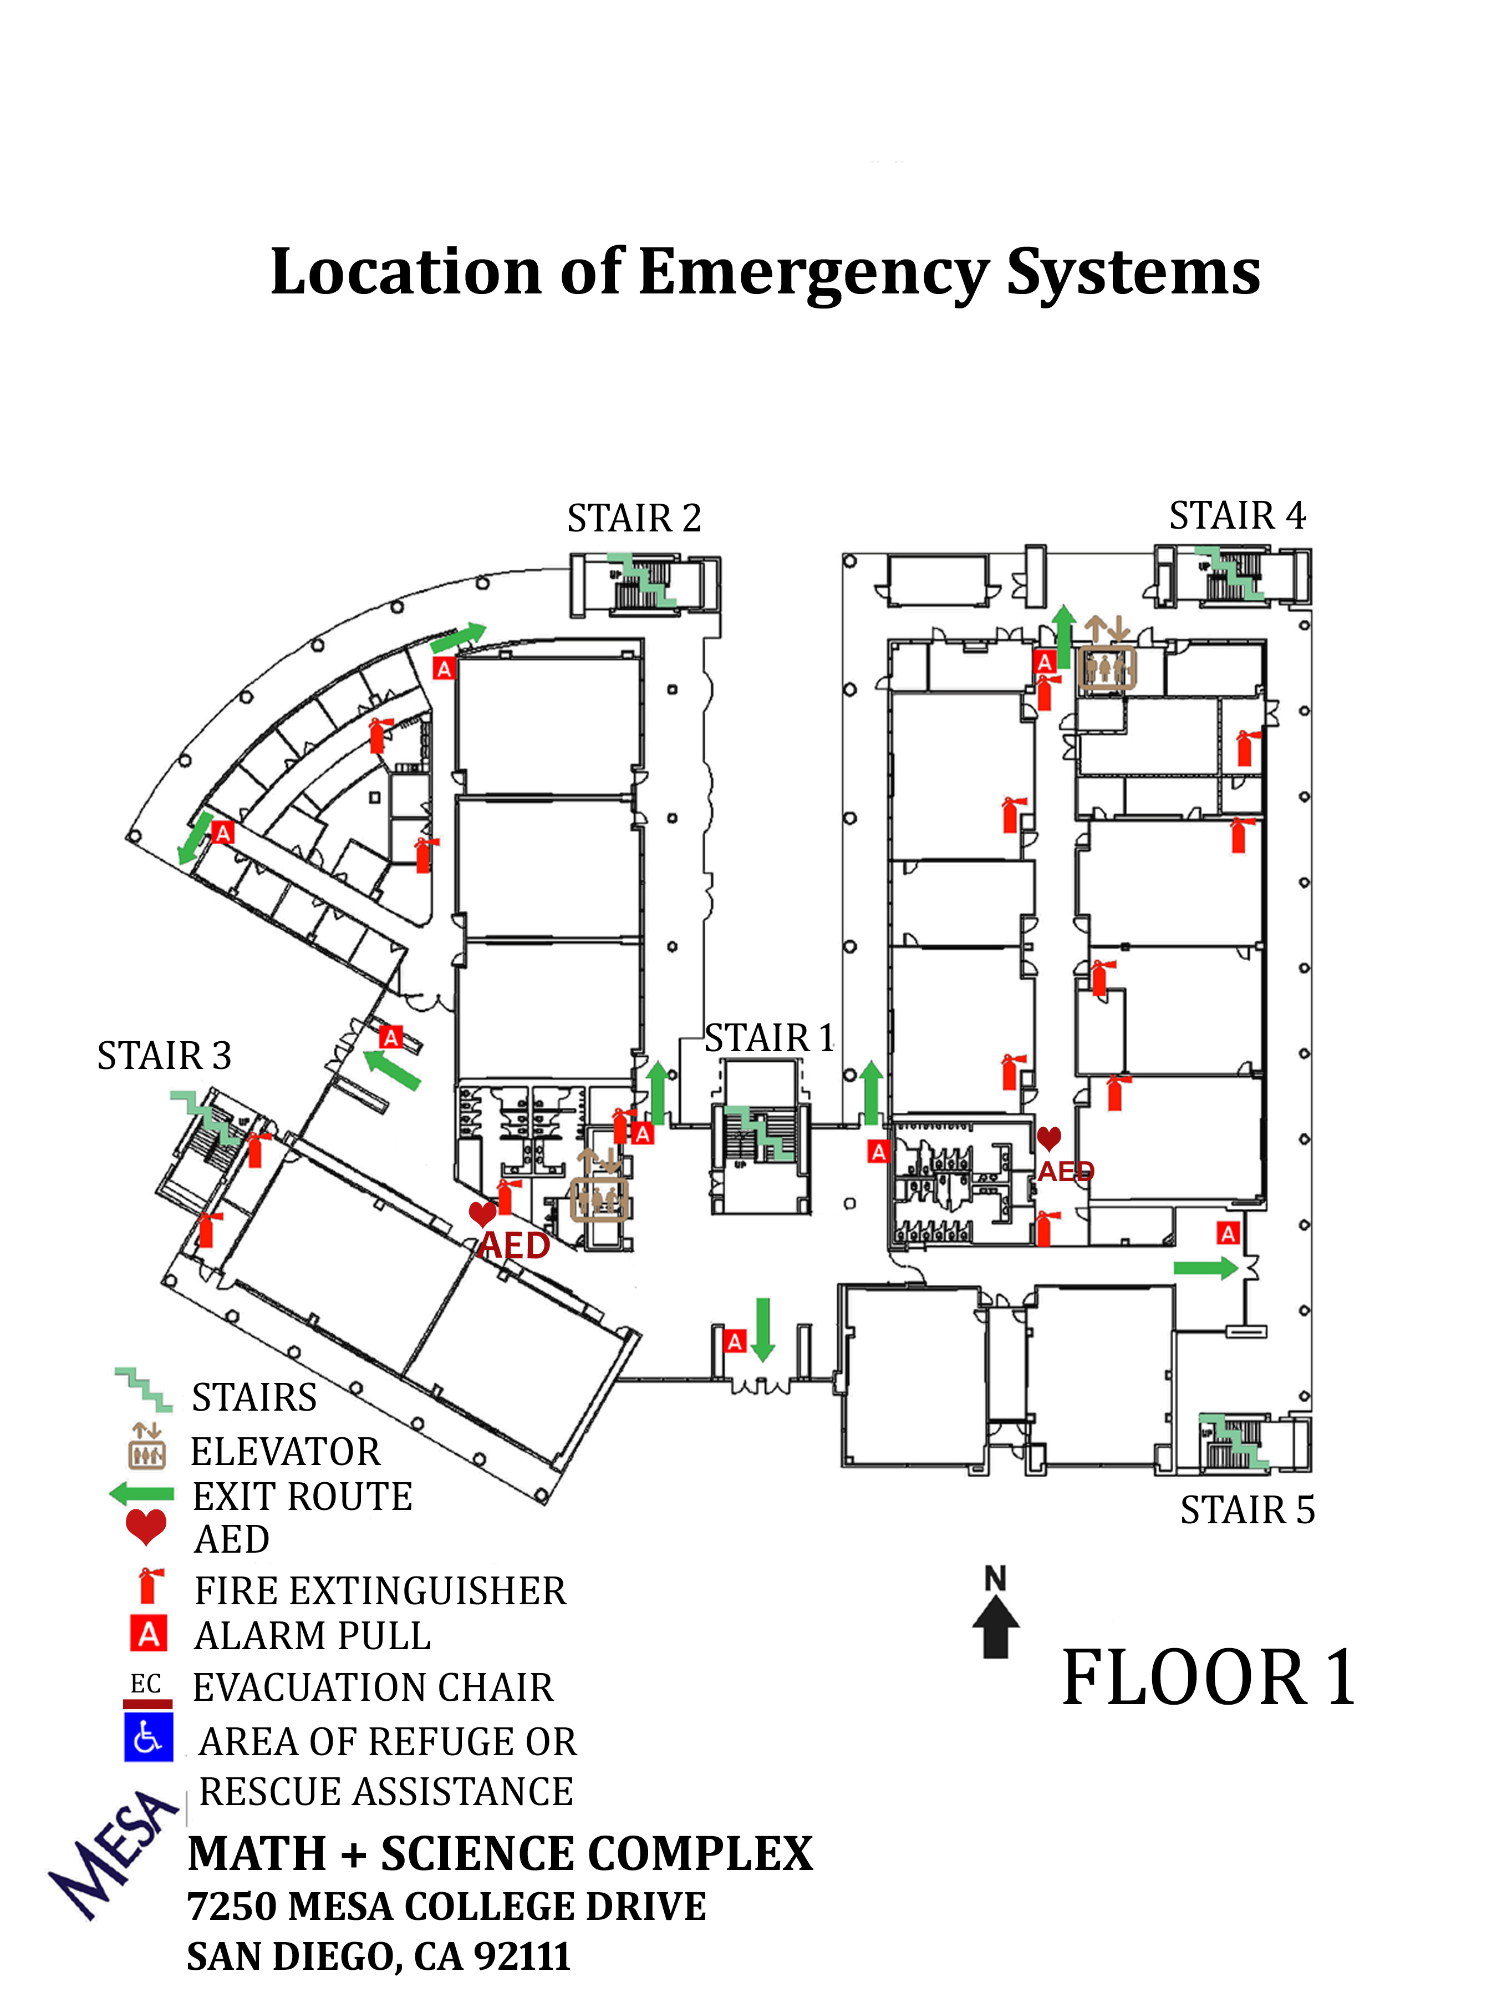

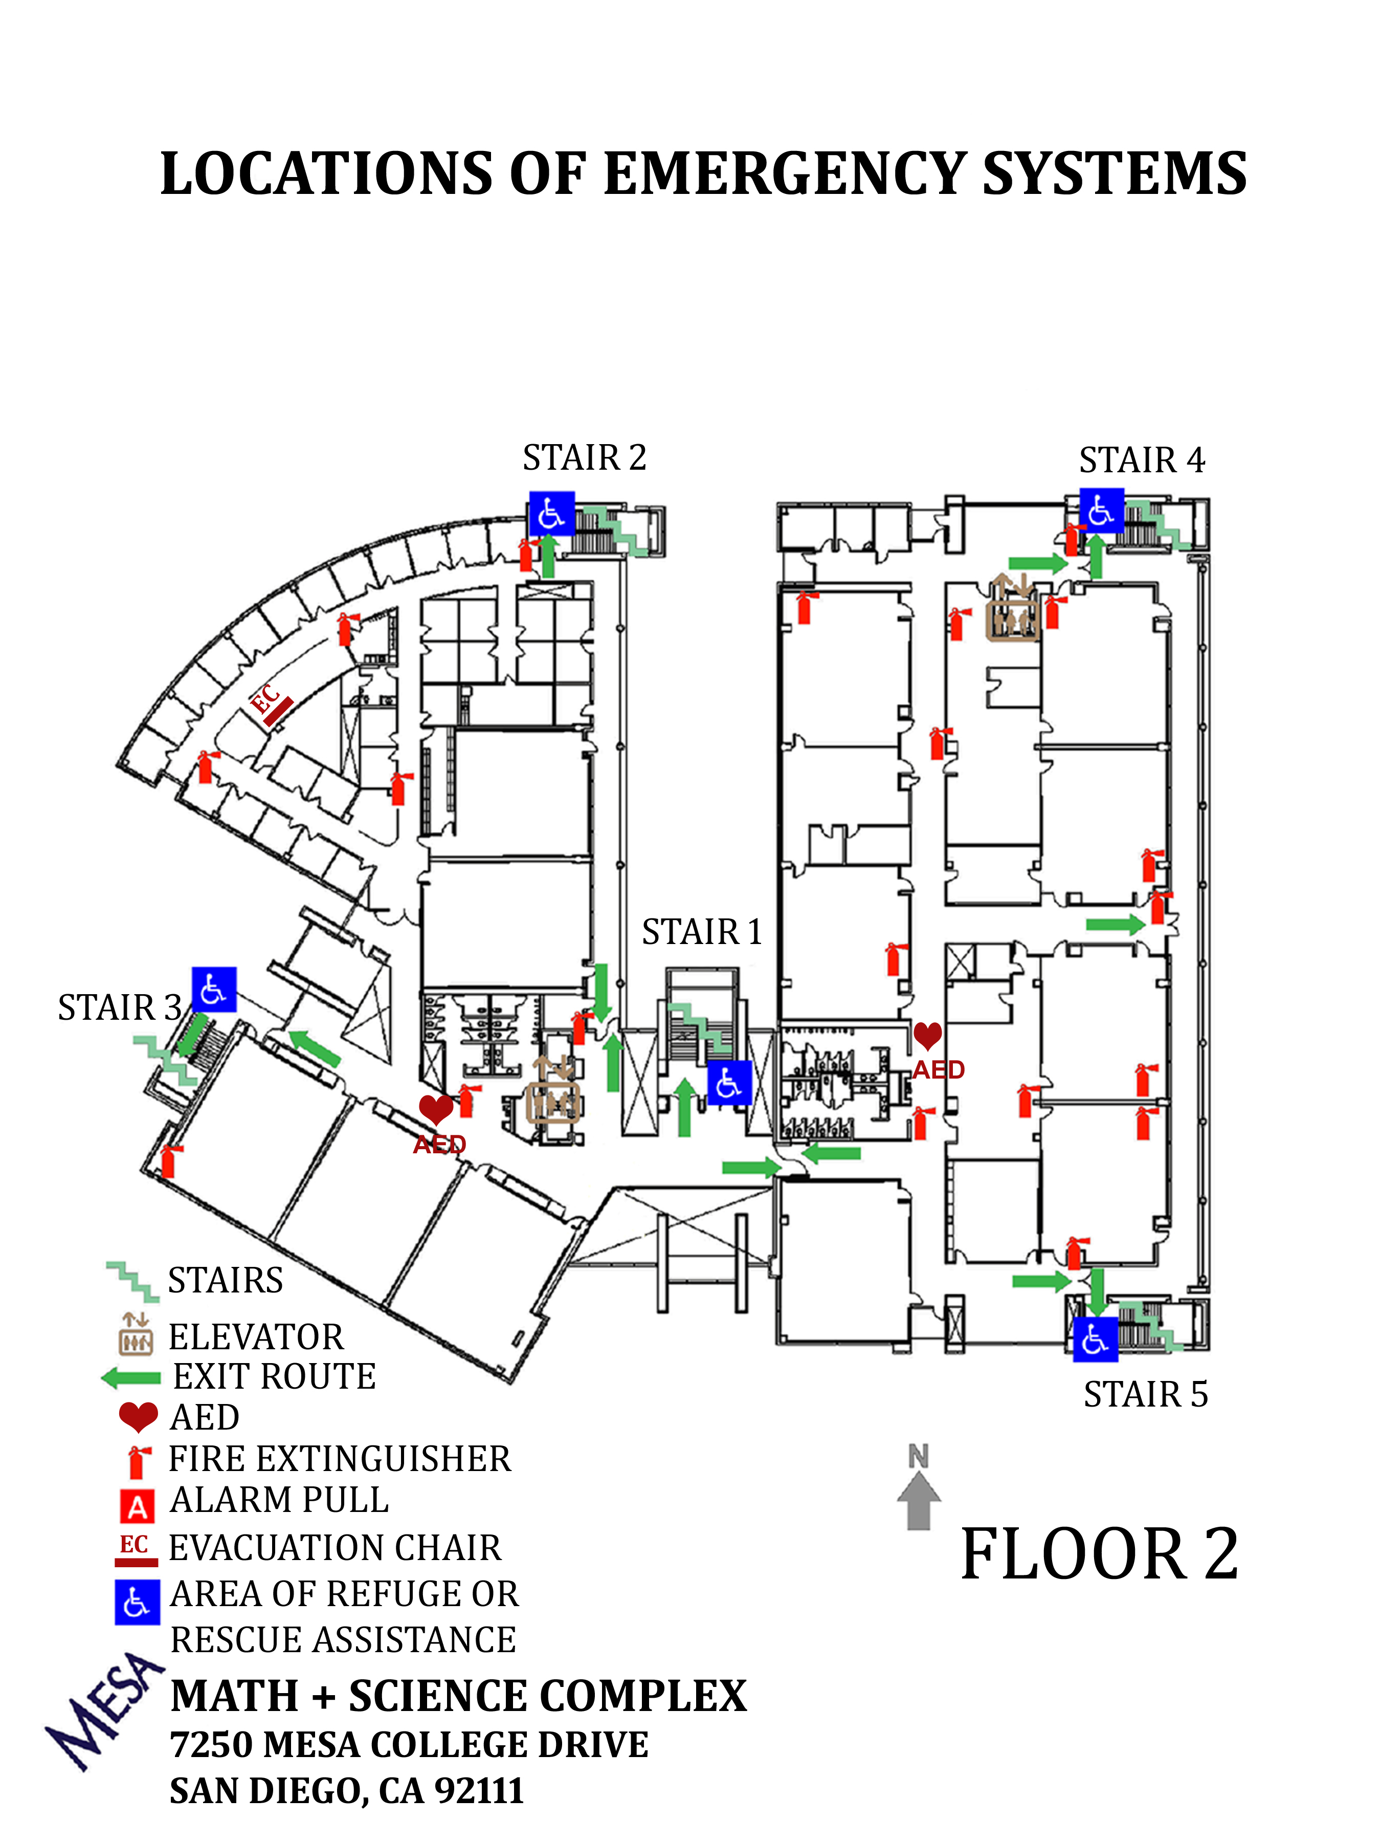

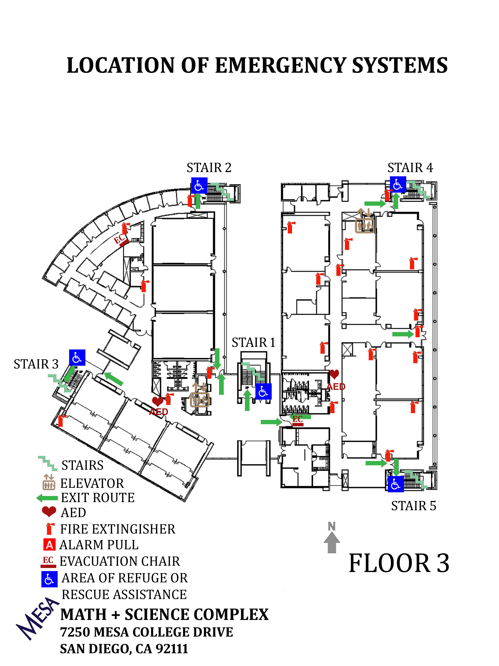

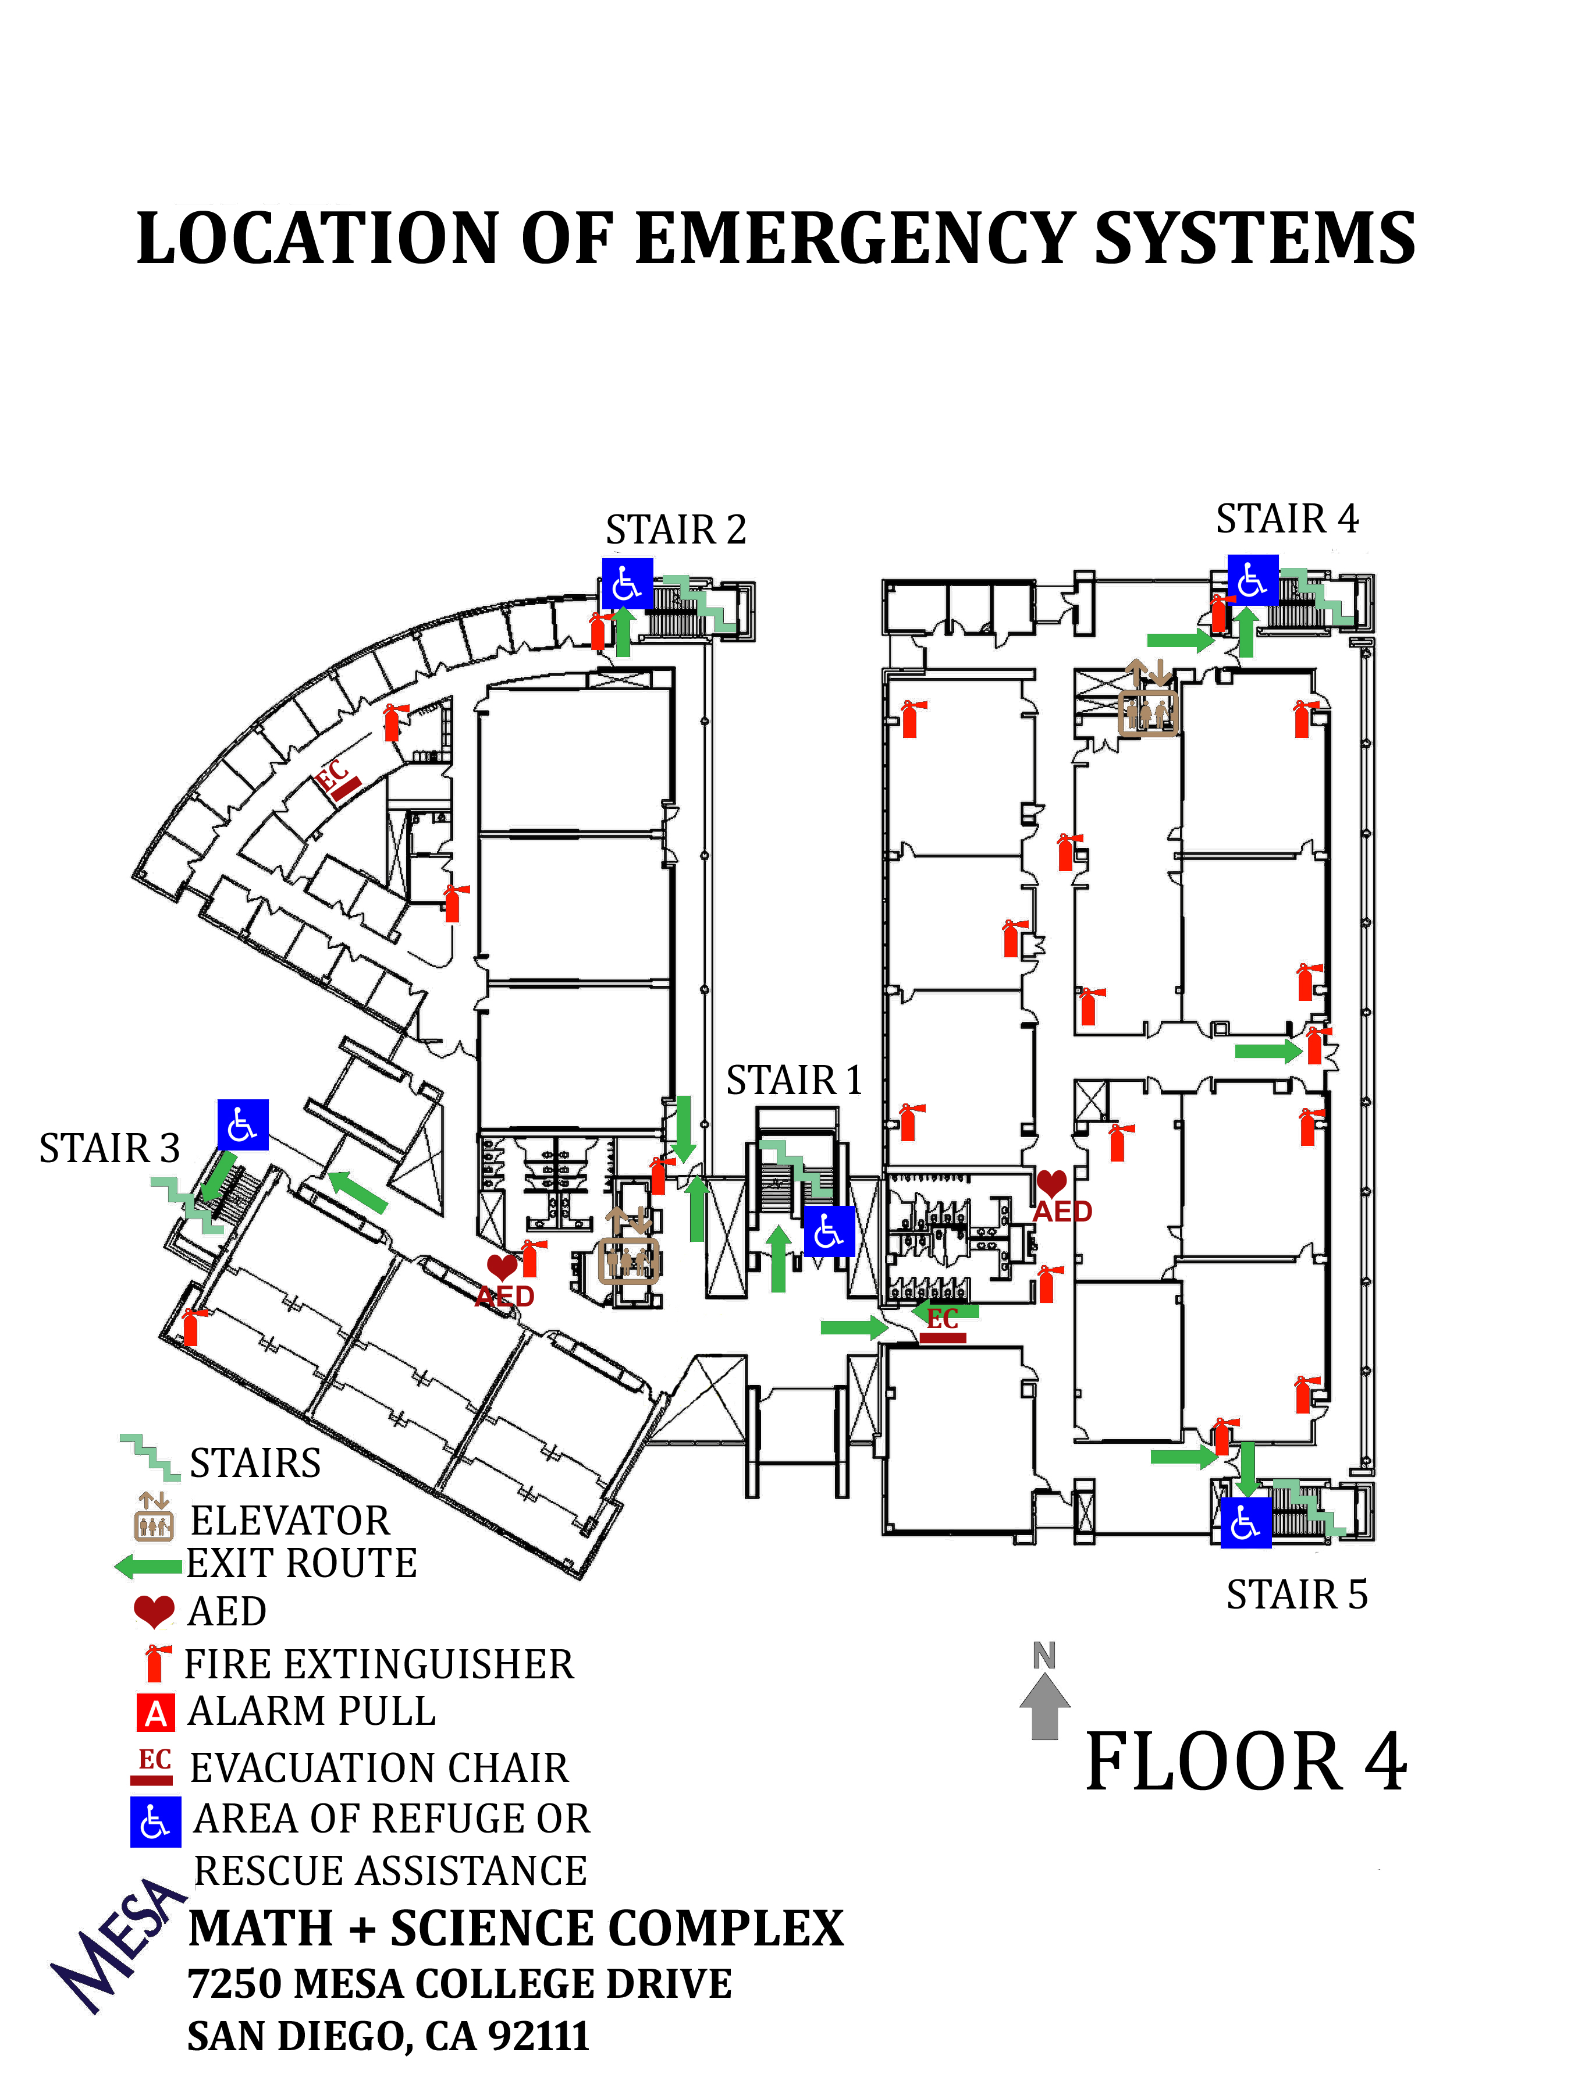

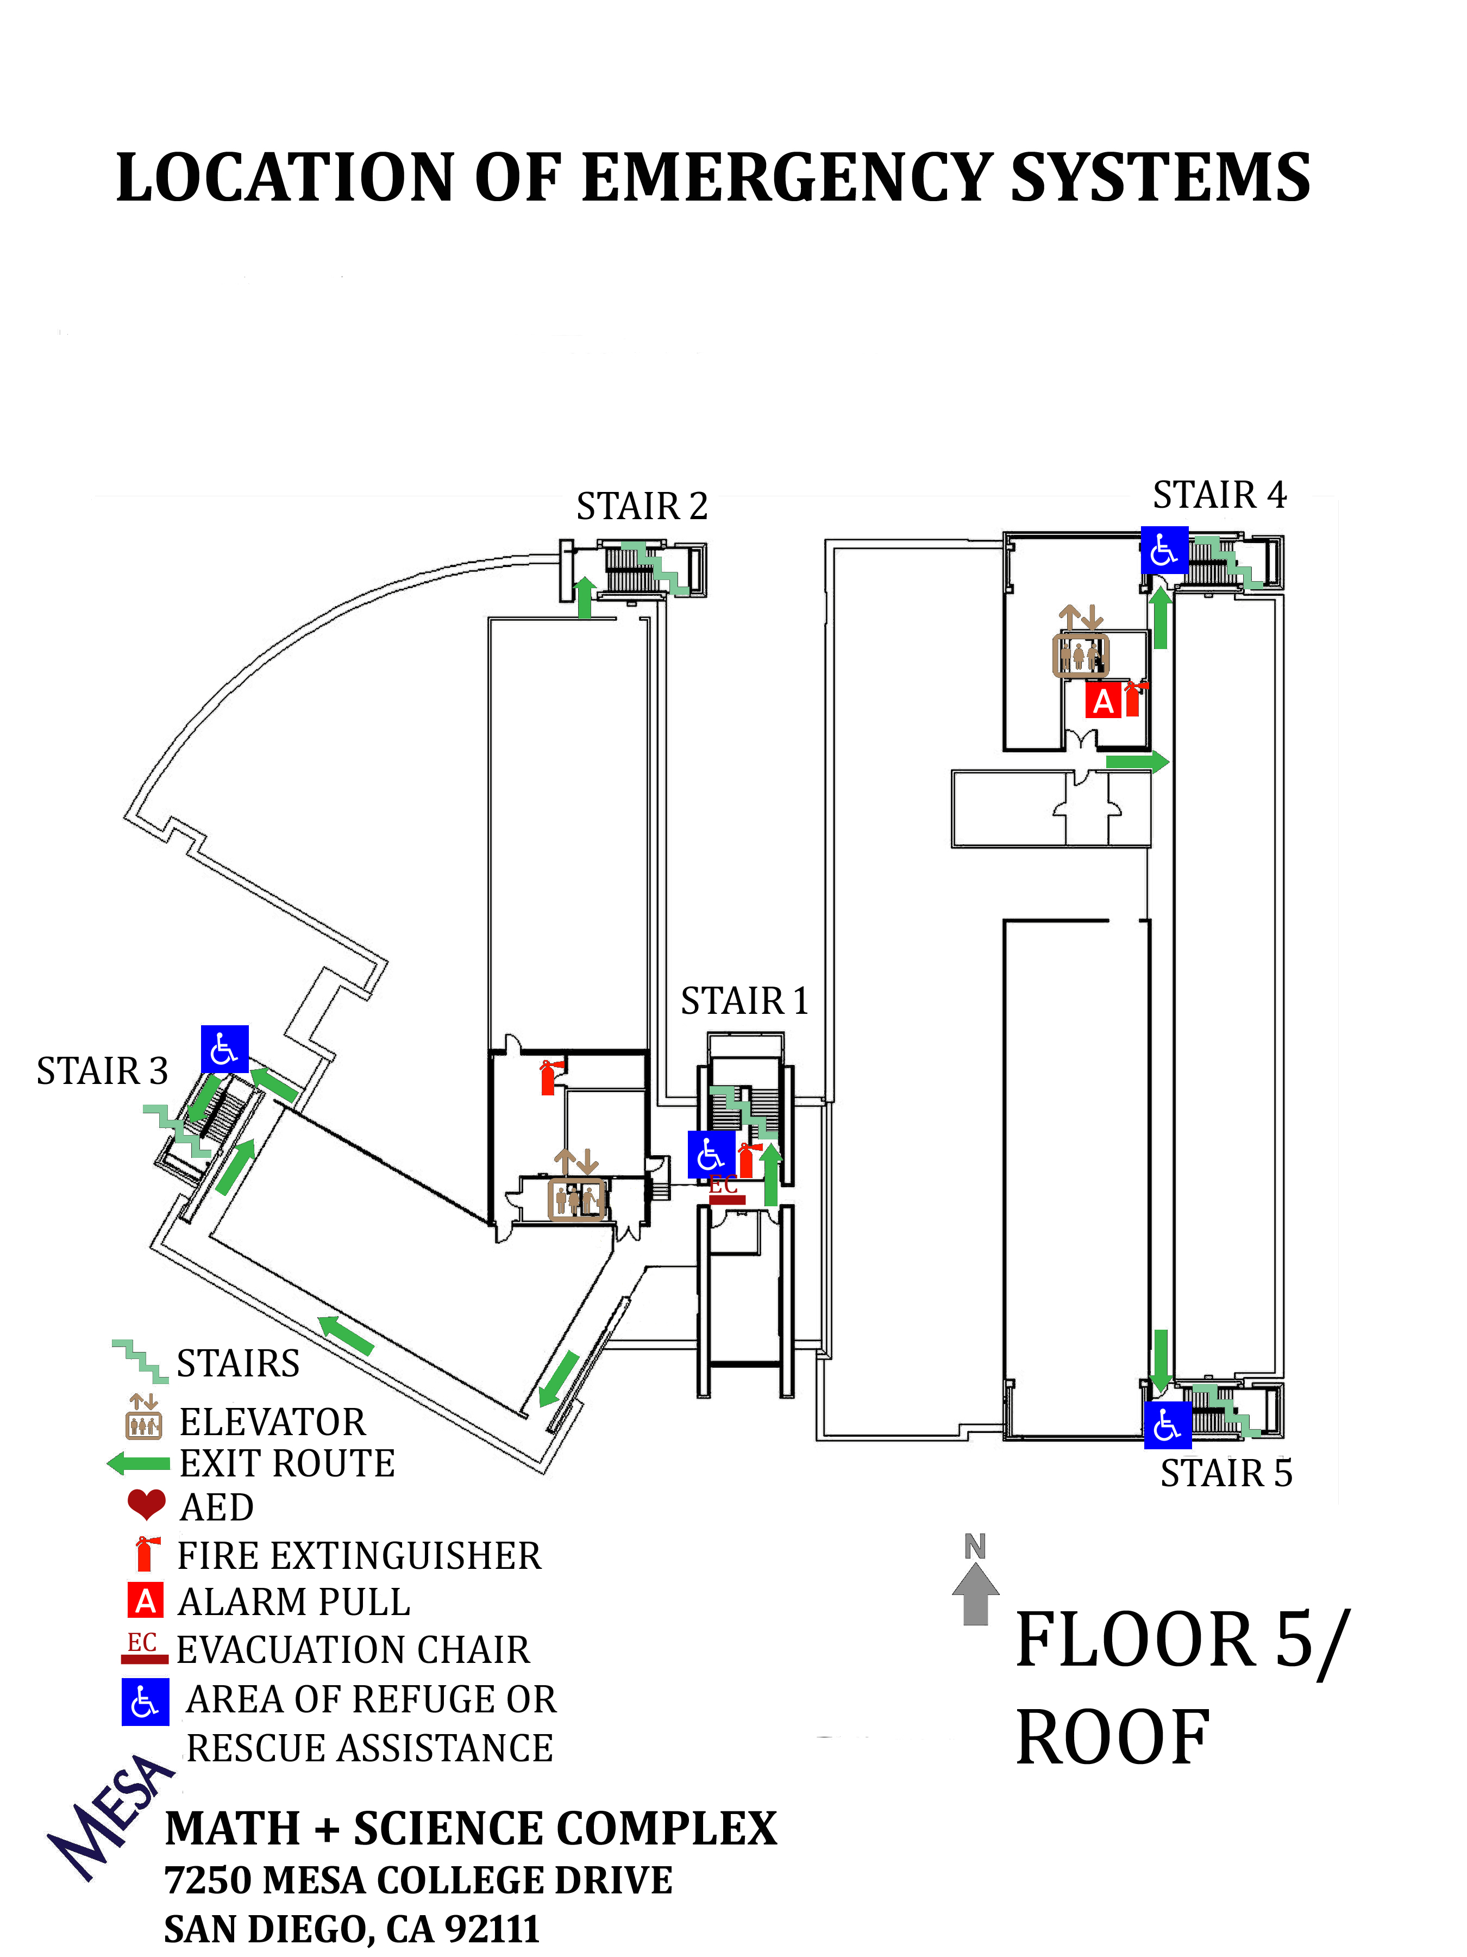

Emergency History Record

In the space below, describe emergencies which have occurred. Include the date, the location within the building, the number of materials affected, recovery procedures, and the resources (time, money, personnel, etc.) needed for complete recovery from the emergency. Also note any vendors or suppliers used in recovery actions and evaluate their performance for future reference. This section should be updated after any emergency occurrence.

EXAMPLE: 9/8/11 - Regional Power Outage occurred at 3 p.m. Campus-wide evacuation, evening classes canceled; immediate cause unknown. Buildings secured at 7:30 pm. ________________________________________________________________________________________________________________________________________________________________________________________________________________________________________________________________________________________________________________________________________________________________________________________________________________________________________________________________________________________________________________________________________________________________________________________________________________________________________________________________________________________________________________________________________________________________________________________________________________________________________________________________________________________________________________________________________________________________________________________________________________________________________________________________________________________________________________________________________________________________________________________________________________________________________________________________________________________________________________________________________________________________________________________________________________________________________________________________________________________________________________________________________________________________________________________________________________________________________________________________________________________________________________________________________________________________________________________________________________________________________________________________________________________________________________________________________________________________________________________________________________________________________________________

Locations Where This Plan Is On File

Location: (Enter information BELOW. List names of individuals as well as different areas)

Name Room

Areas:
Rooms; (Enter room # or description here)

*EXAMPLE*
Department Work Rooms:
Rooms; 115N, 215V, 315V, 415V, 415W

President’s Office
VPA’s Office
Facilities

Others as needed or identified by the VPA

Appendices
(You can add or delete from the list below: Examples of what is currently being used are left attached for use or ideas!)

-Classroom Emergency Quick Guide
-Building Evacuation Observation Report
-Student Accident Report
-Telephone (bomb) Threat Report
-Building Occupancy List
-Important Personnel Contact List

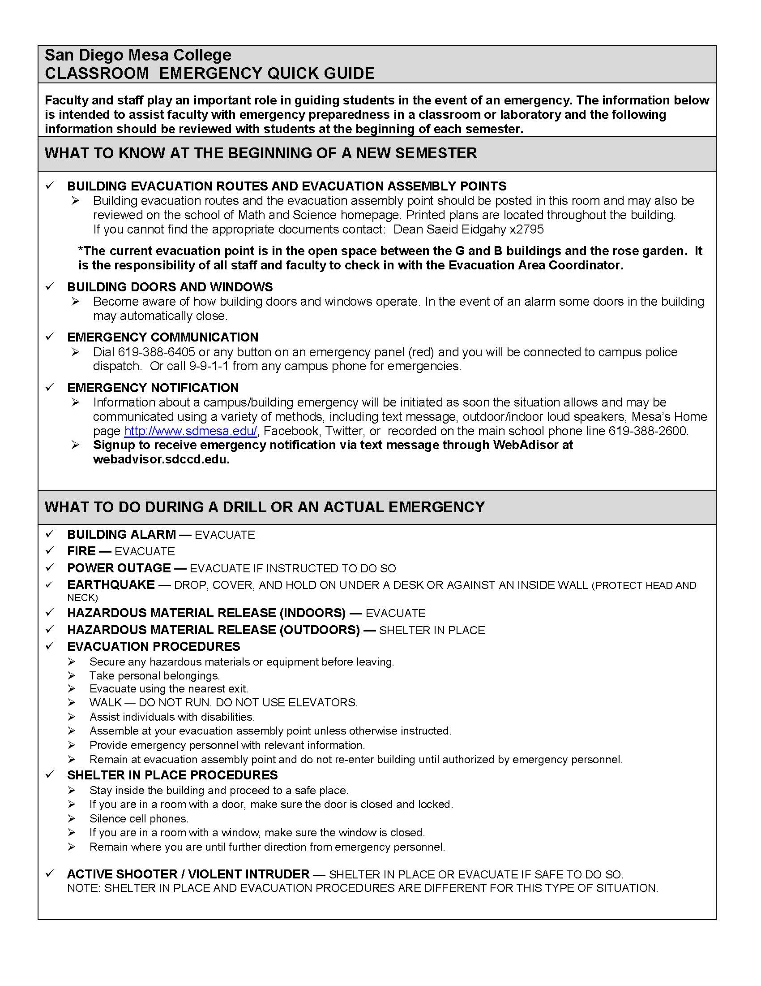

San Diego Mesa College

Building Emergency Evacuation Plan (BEEP)
Observation Report

Date: ___________________

Building/Floor: _________________________

Observer: _____________________________________

Floors observed: _______________________________________________

Time of alarm: ________________________________________________

Time building evacuated: _______________________________________

Did you hear the alarm? _________________________________________

Did all corridor doors close? ______________________________________

Were there any corridor obstructions? ______________________________

Staff Response: _____ Good, _____ Slow, _____ Bad, _____ None

Staff Attitude: _____ Good, _____ Slow, _____ Bad, _____ None

Was Staff confused? _____ Yes, _____ No, _____ Somewhat

Were all visitors/public orderly evacuated? ____ Yes, ____ No, ____ Somewhat

Were Classes Dismissed? _____ Yes, _____ No

Please write down any other comments, observations and or recommendations you may have below: ________________________________________________________________________

________________________________________________________________________

________________________________________________________________________

________________________________________________________________________

________________________________________________________________________

________________________________________________________________________
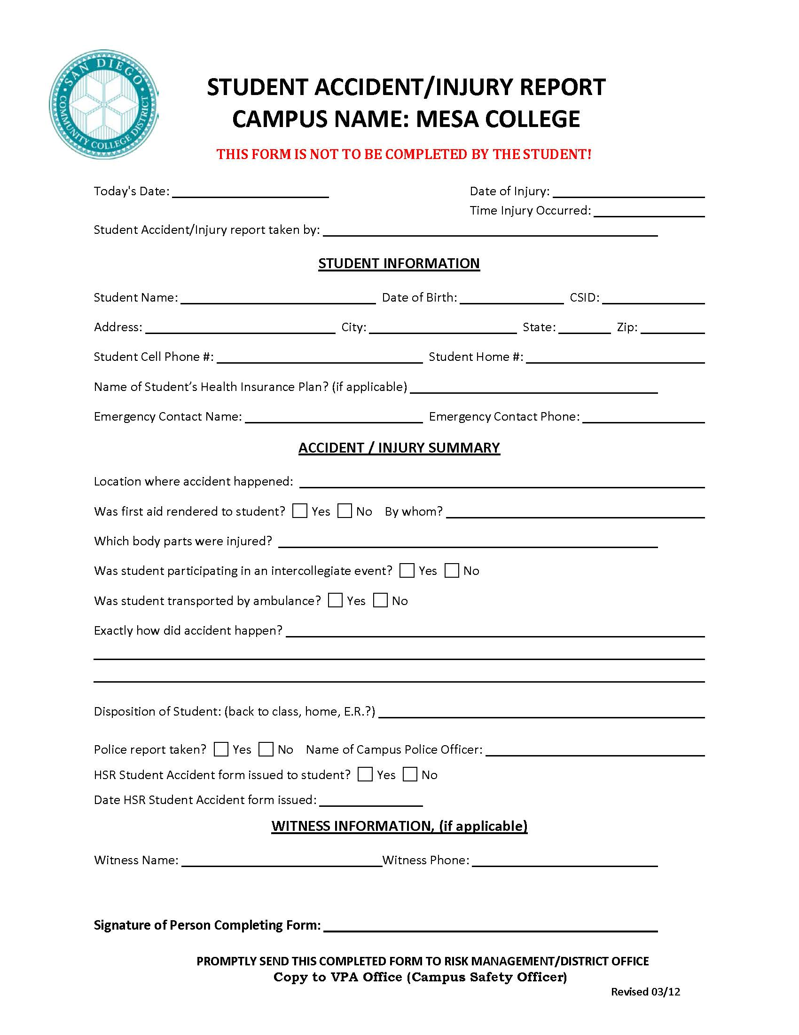
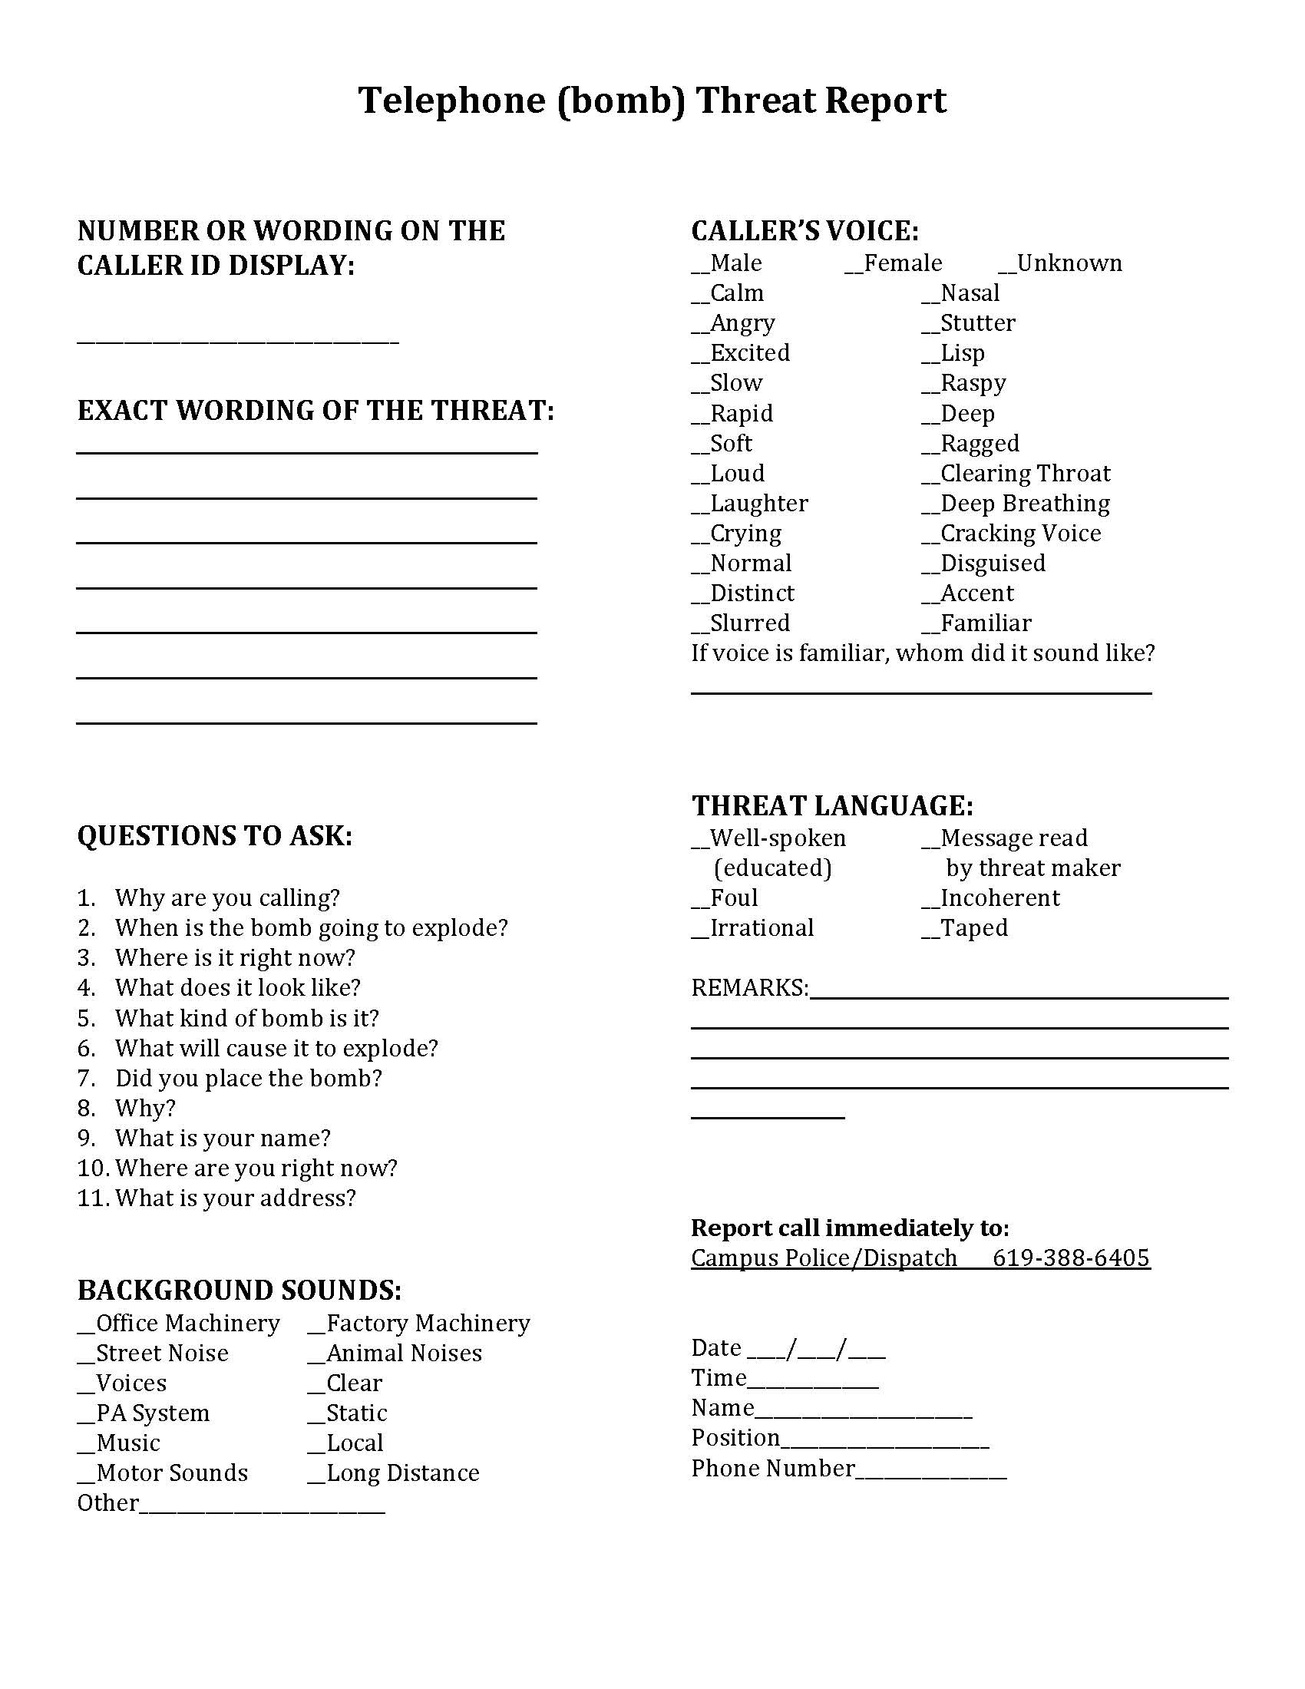

Important Personnel Contact List

NAME | POSITION | PHONE NUMBER
Pamela Luster | President | (619) 388-2721
Rachelle Agatha | VPA | (619) 388-2990
Tim McGrath | VPI | (619) 388-2755
 | VPSS | (619) 388-2678
Saeid Eidgahy | Dean of Math & Science | (619) 388-2795
College Police | College Police | (619) 388-6405
Lina Heil | Public Information Officer | (619) 388-2759
Dave Warczakowski  Eddie Arteaga | Facilities: | (619) 388-2814
Student Health Services | Health Services | (619) 388-2774
Rob Fremland | Department Chair: Chemistry | (619) 388-2422
Paul Sykes | Department Co-Chair: Biology | (619) 388-2616
Jan Clymer | Department Co-Chair: Biology | (619) 388-2785
Don Barrie | Department Chair: Physical Science | (619) 388-2942
Alan Bass | Department Chair: Math | (619) 388-2378
Frank Fernandez | Stockroom Supervisor | (619) 388-2761
 | Crisis Intervention | (619) 388-2538  (619) 898-9719 (pager)
Charlotta Robertson | C-CERT Coordinator Field Liaison | (619) 388-2509
Matt Fay | C-CERT Coordinator ICS Liaison | (619) 388-2634

