The Stand Resource Center
Feedback Survey
This survey was conducted in the fall of 2022 during our first semester fully open and compiled via google docs by Johanna Aleman – Basic Needs Coordinator. Our hope was to find out information about our students as well as their perception of the culture at San Diego Mesa with supporting basic needs.
Who is impacted by the Basic Needs Center?
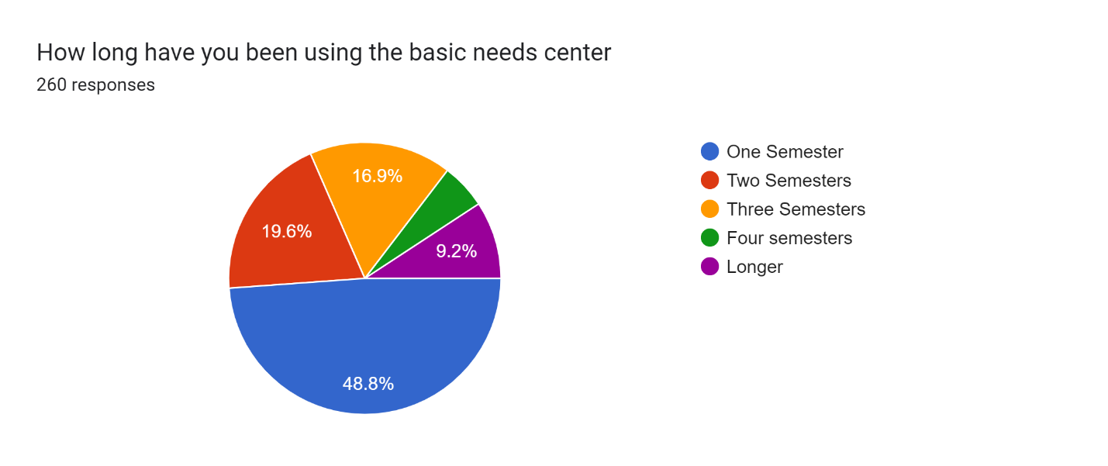
The majority of our students responding have only been using The Stand for one semester.
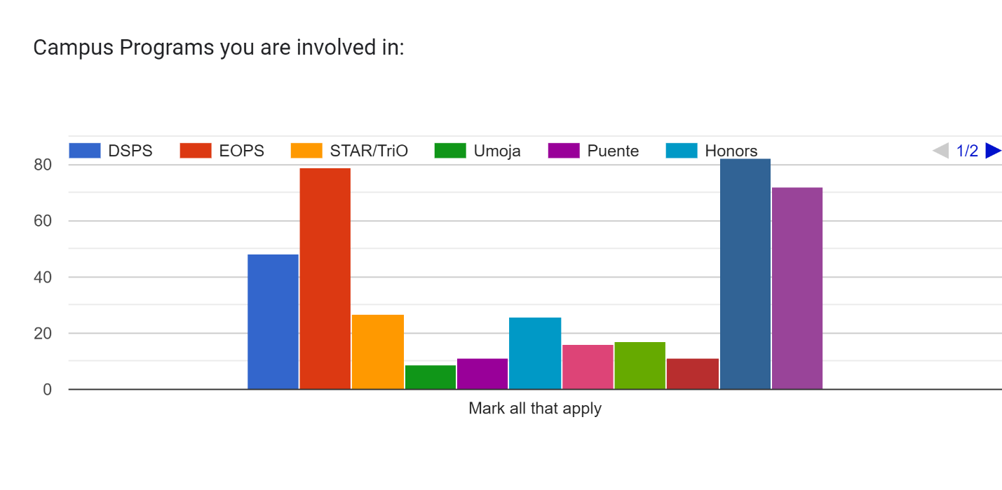
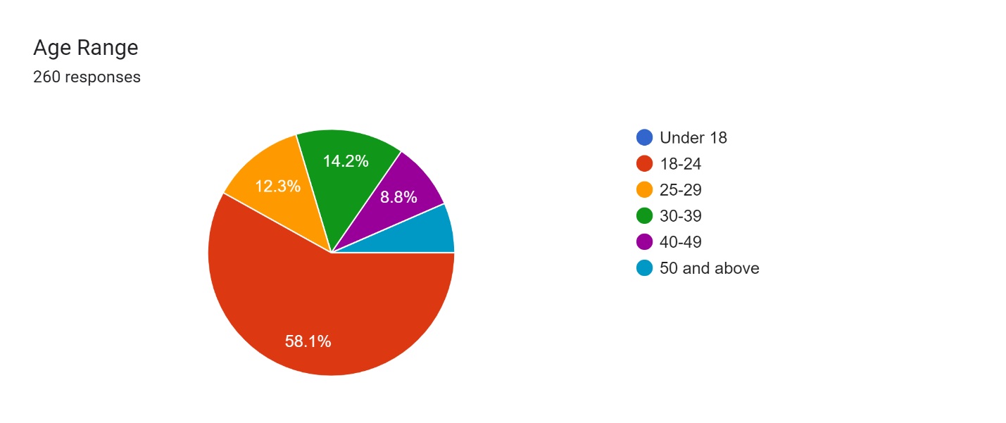
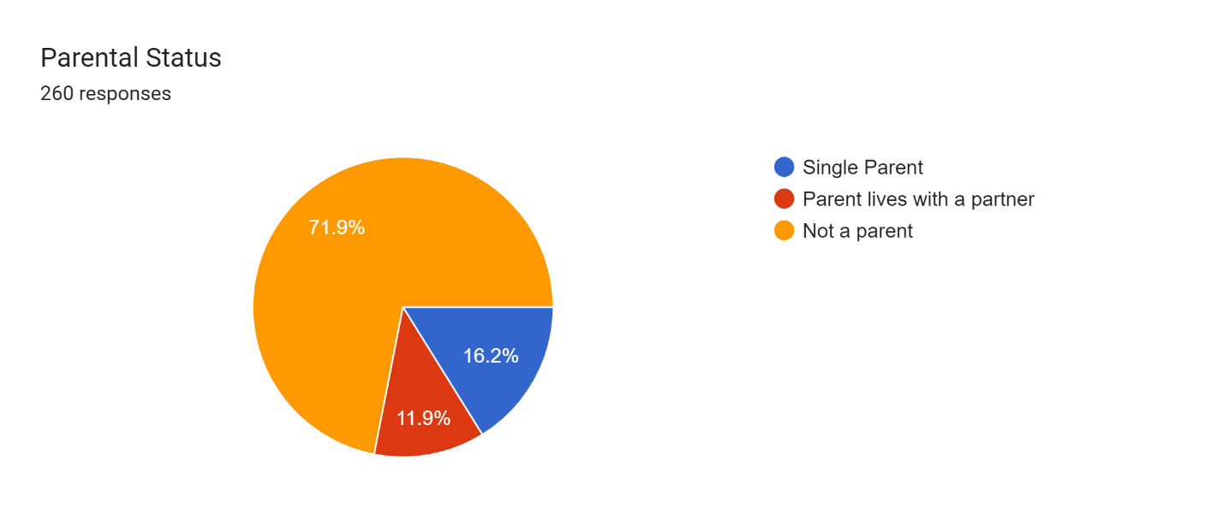
Parental Status is an increasingly noticeable population of students with unique needs as well as basic needs support.

Emergency Food Pantry and Monthly Farmers Markets:
How many students are utilizing the various forms of support we provide on and off campus?
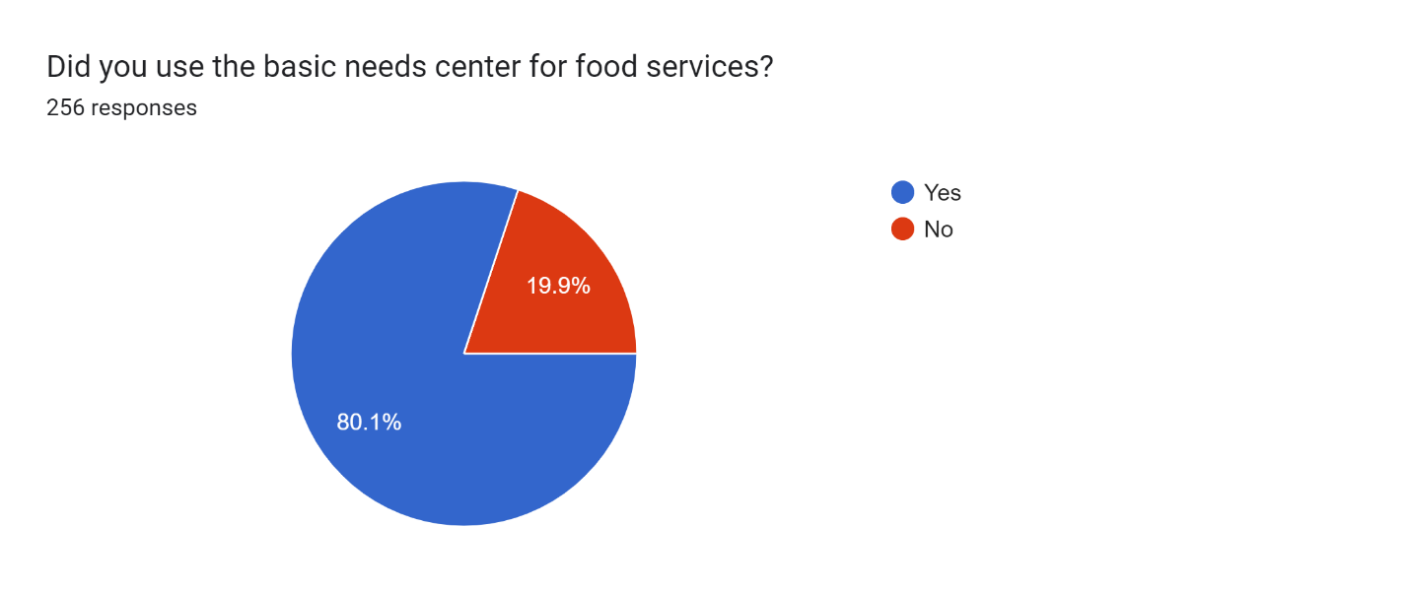
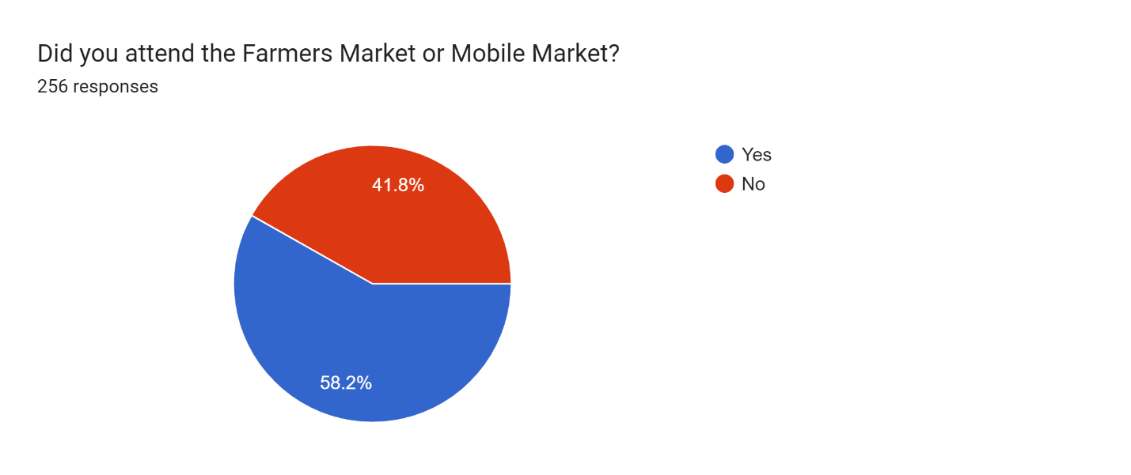
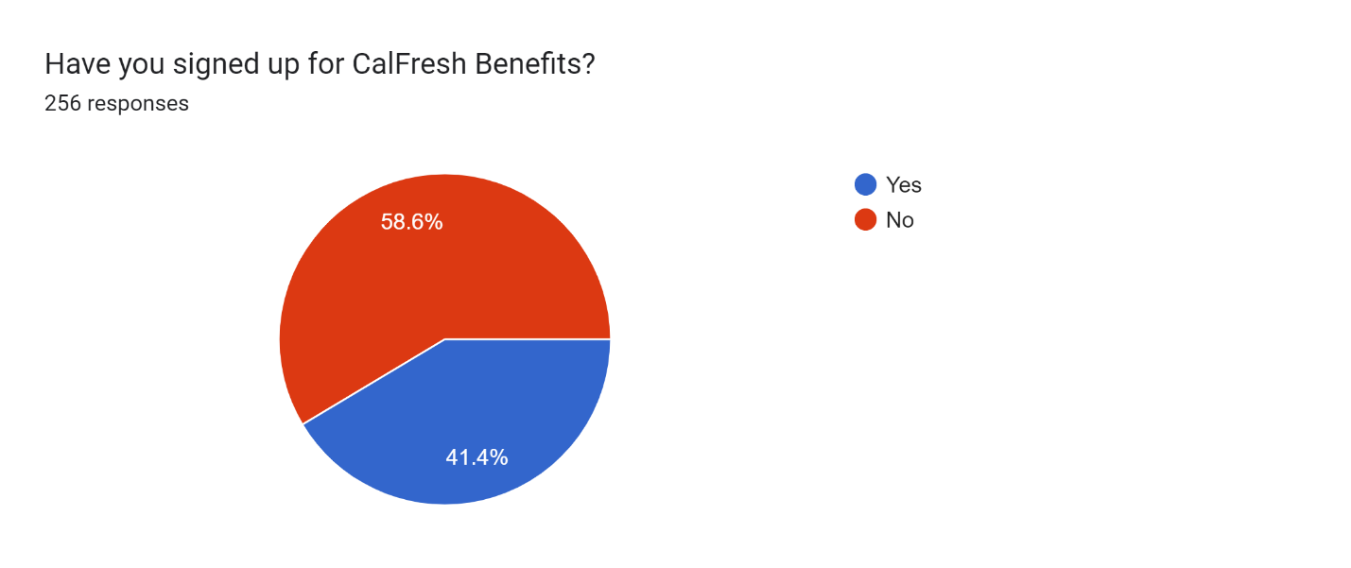

Did Students Utilize our Professional Clothing Closet?
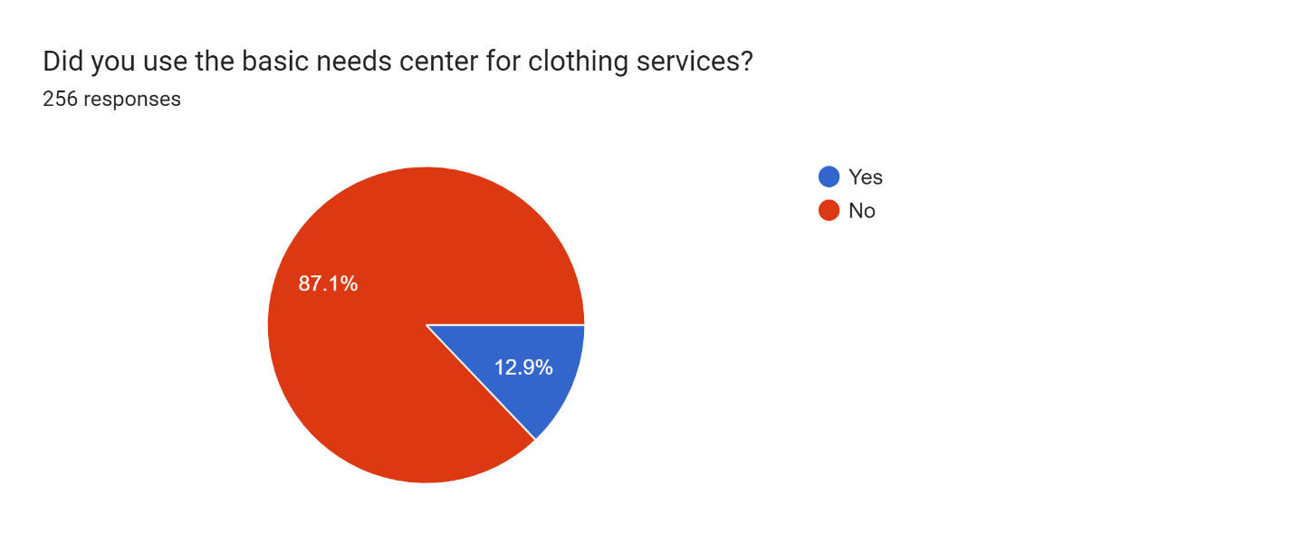
How Satisfied were students when using the Basic Needs Center?
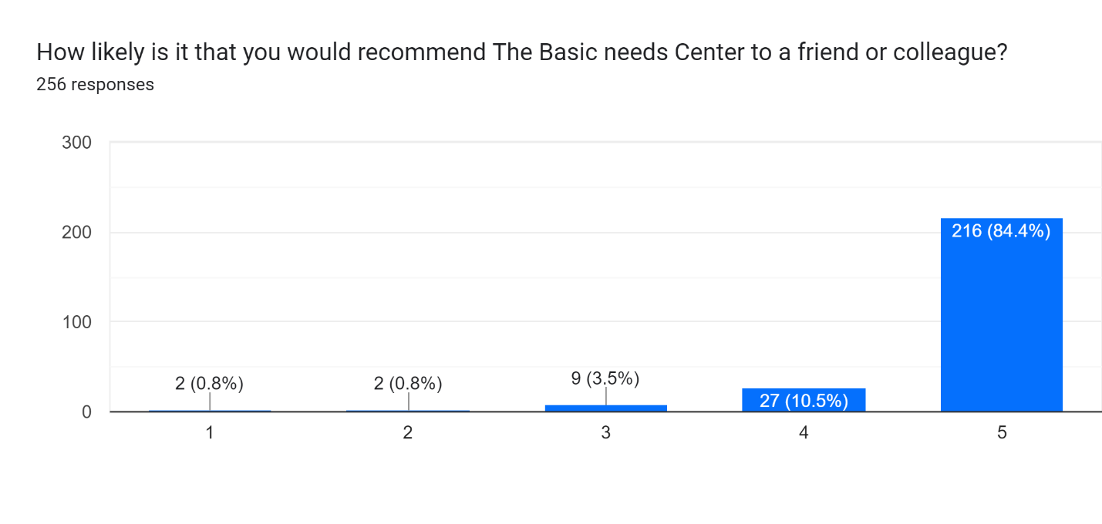
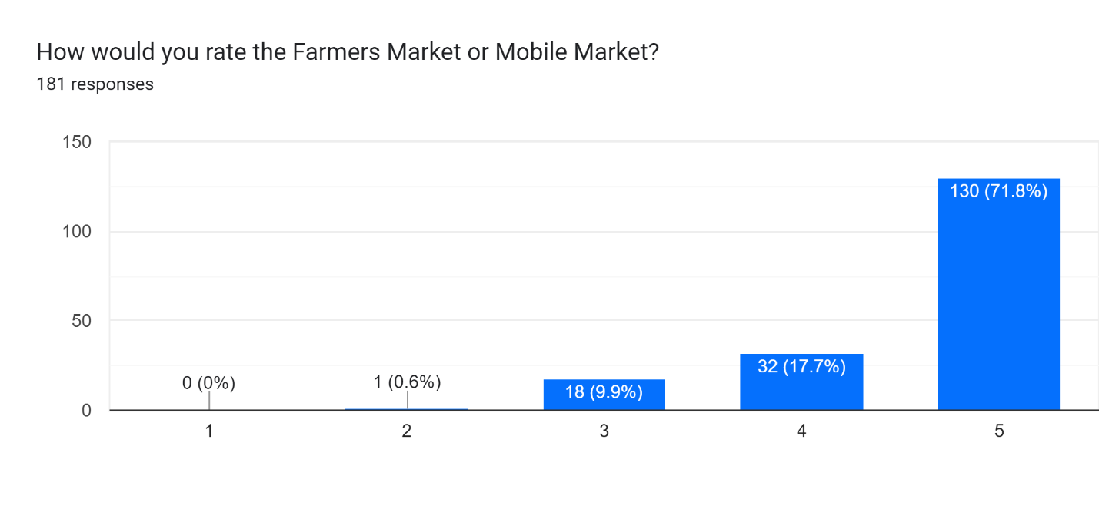
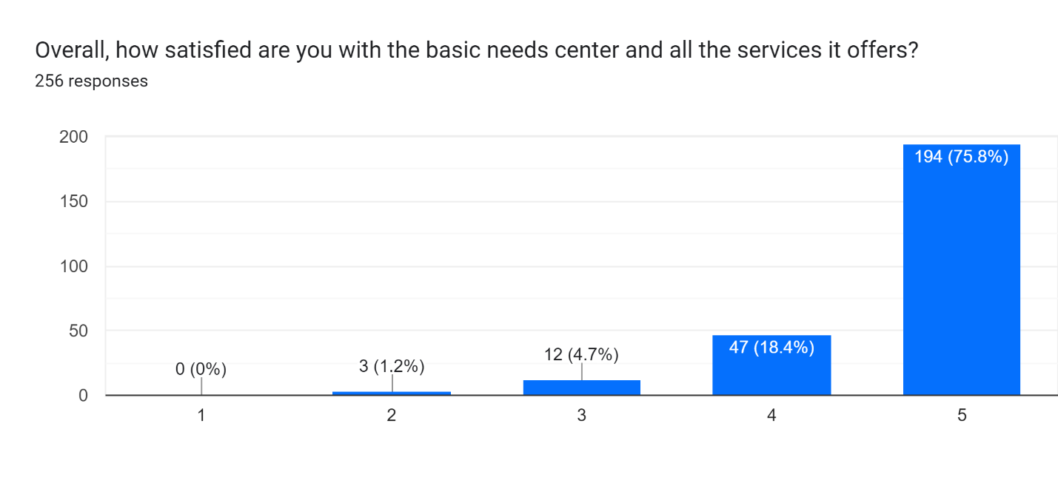
How does our Campus Culture support Basic Needs?
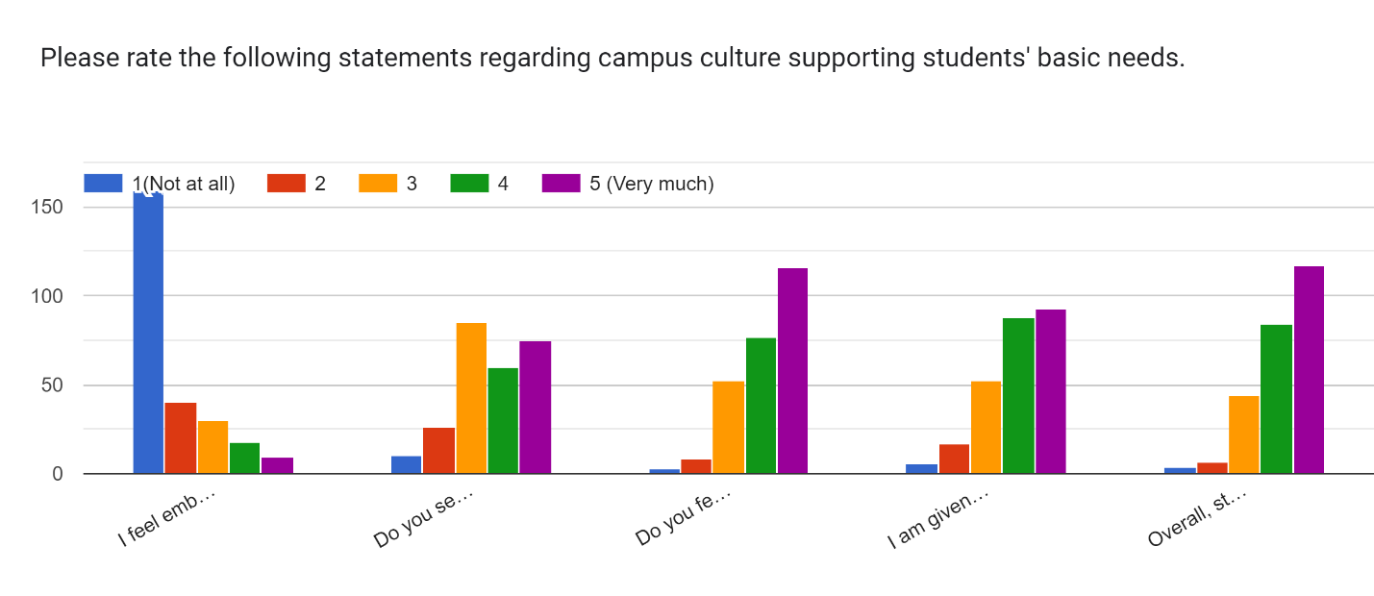
Students were asked how they rate the following statements regarding campus culture supporting students’ basic needs.
- I feel embarrassed to use all the services that the Basic Needs Center provides.
- Do you see a diverse group utilizing basic needs services and/or events?
- Do you feel included and welcomed on campus?
- I am given sufficient resources to succeed in my studies
- Overall, students, faculty, staff, and administrators contribute to a positive campus climate.
The majority of students noted that they were not embarrassed to utilize the services, and it seems that the campus community contributes to a positive campus climate were students feel welcome. There was a high level of neutral responses to seeing diverse groups utilizing basic needs supports, we are unsure if this is just not something our students are overly concerned with or if we need to improve diversity at these events. Finally, while students mostly state they are given sufficient resources, there is room for improvement.
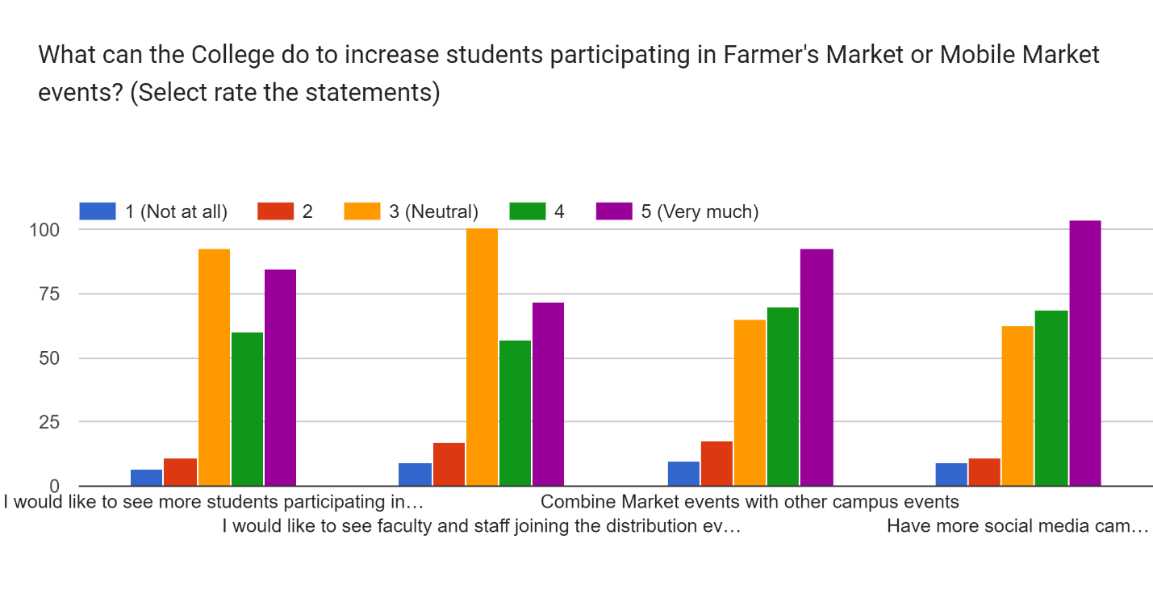
Coupled with the campus climate question, we were interested to see how students felt we could improve our large scale market style food distributions. Students were asked to rate the following statements regarding these distribution events.
- I would like to see more students participating in the produce distribution event regardless of their income status.
- I would like to see faculty and staff joining the distribution events.
- Combine Market events with other campus events
- Have more social media campaigns to call attention to food insecurity concerns
It appears that in regards to our market events students were mostly neutral in response, but clearly would like more crossover with other campus events and for The Stand to provide more social media postings about events.

Mesa Students Statements on the positive impact of The Stand:
“Times are hard and its nice knowing that their is a space for students to be able to get aid if needed for their basic needs. It takes some of the stress off so we can focus on studying and being successful on our educational journey.”
“I’m glad there’s a service like this on campus. Food stamps are scarce and run out quick that’s why having a service like The Stand at school is essential.”
“Overall I know that I can count on the Stand for support to provide me with a quick snack to get me through the morning and snack time. My stress levels decrease knowing that I have something to go to that will help me continue my studies”
“As I have been going through homelessness, the stand has been very supportive both mentally and physically. I have been able open up about my situation when everyone at the Stand and they always give great encouragement. The Stand also provided me with helpful resources like food, clothes and even provided me with a bus pass to ease my commute. They are the reason I feel so motivated and content with my path to success. I have been able to get more help through The Stand than though our own county. I’m really thankful we have a place like The Stand at school. It really takes away the stigma there is when it comes to asking for help.”
“The Stand it has helped me with food security, i take snacks back to my kids, i can get powdered milk for my youngest who still drinks a bottle, It also allowed me to have more clothes when i didn't have anything left to wear and no money for laundry i knew it was going to be okay because i could literally walk in and walk out with a freshly clean outfit and not worry about my appearance.”
“Overall my experience with the stand has been great, the staff is friendly and supportive no matter who you are and they want to make sure you can get what you need. Having an accessible program like that is so inspiring and so helpful and it makes me proud amongst other things to say that Im an Olympian!”

“Most students, myself included, are on a tight budget and food is a human right, but unfortunately affordable, healthy, and filling options are sometimes inaccessible on the go. The Stand has given me opportunity to stay on campus a bit longer to be able to study/ meet with groups, and help me focus on my classwork rather than what's for lunch. I feel as if my school cares about it's students wellbeings, because actions speak louder than words. And having this resource on campus speaks volumes.”
“I do not have much money, and the stand has always given me some food in my belly when I needed it. I have depended on The Stand in the past and am really glad this campus does this for struggling students. I hope The Stand continues to go on because it really helped me and I hope it helps someone else.”

